Select Committee on Rural Housing and Second Dwellings Reform
Rural housing and second dwellings reform
Published on 30 March 2026 according to Standing Order 238

New South Wales. Parliament. Legislative Council. Select Committee on Rural Housing and Second Dwellings Reform. Report no. 1.

Rural housing and second dwellings reform

"March 2026"

Chair: Hon John Ruddick MLC



ISBN: 978-1-923392-18-2
Table of contents
Terms of reference v
Committee details vii
Chair’s foreword viii
Recommendations ix
Conduct of inquiry xi
Chapter 1 Overview of the regulatory framework for second dwellings in New South Wales 1
The planning system in New South Wales 1
Environmental Planning and Assessment Act 1979 1
Environmental planning instruments 2
Development Control Plans 3
The regulation of secondary dwellings and dual occupancies 4
Secondary dwellings 4
Dual occupancies 6
Development approval pathways 7
Complying development 7
Development applications 8
The draft State Environmental Planning Policy (Housing) Amendment (Second Dwellings in Rural Zones) 2025 9
Terminology 10
Chapter 2 Key issues 11
The social and economic benefits of second dwellings in rural areas 11
Alleviating housing concerns 11
Supporting multigenerational living and farming families 13
Economic benefits 17
Key challenges in the current regulatory system for second dwellings 18
Restrictions on secondary dwellings and dual occupancies 19
Inconsistencies across the state 21
Challenges with the development application process 23
Restrictions on other structures 26
Existing unauthorised structures 28
Subdivision 28
Local government perspective 31
Strategic planning 31
Impacts on agriculture and biodiversity 32
Impacts on infrastructure and services 33
Transitional arrangements and monitoring of policy outcomes 35
Committee comment 36
Appendix 1 The Draft State Environmental Planning Policy (Housing) Amendment (Second Dwellings in Rural Zones) 2025 41
Appendix 2 Submissions 47
Appendix 3 Witnesses at hearings 51
Appendix 4 Minutes 54

Terms of reference

(1) That a select committee be established to inquire into and report on reforms to facilitate the construction of second dwellings in rural zones, and in particular:
(a) planning instruments and development controls to facilitate the construction of second dwellings in rural zones in New South Wales, excluding Greater Sydney, with an emphasis on Outer Metropolitan Local Government Areas, and in particular the document entitled "State Environmental Planning Policy (Housing) Amendment (Second Dwellings in Rural Zones) 2025"
(b) potential amendments to the State Environmental Planning Policy (Housing) 2021 (Housing SEPP), the State Environmental Planning Policy (Exempt and Complying Development Codes) 2008 (Codes SEPP), and related instruments to enable flexible, streamlined, and liberalised approval pathways for second dwellings on rural-zoned land
(c) the benefits and risks of permitting second dwellings on RU1–RU6, C3 and C4 zoned lands, including via complying development
(d) the suitable interaction between the Housing SEPP and/or Codes SEPP and provisions in Local Environmental Plans under section 3.28 of the Environmental Planning and Assessment Act 1979
(e) the impact of removing restrictions on dwelling size, attachment, and internal lot distance and implications of enabling second dwellings to be larger than, or function as, the primary dwelling
(f) the role of elevation criteria and 1-in-100-year flood mapping in determining permissibility and the use of performance-based solutions for flood-prone lands (e.g., elevation certification), other land-based hazards and environmental impacts
(g) the interaction between second dwellings and potential impacts on rural activities and productive capacity of land for agriculture, including feasibility and implications of allowing second dwellings without subdivision
(h) the use of non-discretionary, zone-specific development standards and their interaction with merit based assessment in complying pathways and legal frameworks for tenancy in common, co-ownership, and strata-like arrangements on rural land
(i) mechanisms to streamline the development application and Complying Development Certificate (CDC) processes
(j) the adequacy of existing infrastructure (eg sewerage, access roads) for servicing second dwellings and potential impacts of reforms on housing affordability, multigenerational living, and rural population growth
(k) transitional arrangements and monitoring of policy outcomes, and
(l) any other related matters.
(2) That the committee report by 31 March 2026.

The terms of reference for the inquiry were referred to the committee by the Legislative Council on 6 August 2025.

Committee details
Committee members
 | Hon John Ruddick MLC | Libertarian Party | Chair
 | Hon Scott Farlow MLC | Liberal Party | Deputy Chair
 | Hon Mark Buttigieg MLC | Australian Labor Party
 | Hon Anthony D’Adam MLC | Australian Labor Party
 | Hon Wes Fang MLC | The Nationals
 | Ms Sue Higginson MLC | The Greens
 | Hon Emily Suvaal MLC | Australian Labor Party
Contact details

 | Website | www.parliament.nsw.gov.au
 | Email | ruralhousing@parliament.nsw.gov.au
 | Telephone | (02) 9230 3081

Secretariat
Alice Wood, Principal Council Officer
Isabella Azzena, Senior Council Officer
Philip Kolotas, Administration Officer
Shaza Barbar, Director

Chair’s foreword
There is a pressing need for rural housing reform. Rising property prices and rental costs are placing increasing pressure on families, forcing many to move away from their communities, separating generations. This has broader social implications, including reduced support for elderly family members and increased strain on childcare and aged care systems. In addition to this, farming families are not receiving adequate support to enable them to operate their farms effectively and sustainably. Addressing these challenges requires practical, accessible and cost-effective solutions.
Permitting second dwellings in rural and conservation zoned land, is a simple, effective and low-cost solution. Evidence presented to the committee highlights that enabling families to live closer together, can support multigenerational living, strengthen communities and provide tangible economic benefits to landowners and local economies.
The committee was concerned by the number of restrictions and regulations imposed on second dwellings and the challenges faced by landowners in obtaining council approval. Current planning controls and approval pathways for second dwellings were widely regarded as overly restrictive, complex, time-consuming and costly by stakeholders. Landowners face significant barriers in navigating council approval processes, which are further complicated by inconsistencies in how local planning instruments are interpreted and applied across the state. It is clear that the current regulatory framework for second dwellings is too restrictive and is in need of urgent reform.
The reforms proposed within this report to liberalise the construction of second dwellings on rural and conservation zoned land present an opportunity to make a meaningful difference. By removing unnecessary barriers and providing clear, consistent pathways, the NSW Government can enable second dwellings to become a viable and practical solution for many rural landholders, helping to ease housing concerns and support stronger, more connected communities.
The inquiry received 292 submissions and heard from 30 witnesses over the course of three public hearings, one of which was held in Tweed Heads. The committee also conducted site visits in the Hawkesbury region. Participants offered a range of perspectives and insights, informed by varied personal and professional backgrounds. On behalf of the committee, I thank all who contributed to this inquiry.
I would like to thank committee members for their considered engagement throughout the inquiry. I also extend my thanks to the dedicated committee secretariat and Hansard for their professional support.

Hon John Ruddick MLC

Committee Chair

Recommendations
Recommendation 1 37
That the NSW Government consider amending the State Environmental Planning Policy (Housing) 2021 (Housing SEPP), the State Environmental Planning Policy (Exempt and Complying Development Codes) 2008 (Codes SEPP), the Standard Instrument (Local Environmental Plans) Order 2006, and any other necessary planning instruments and legislation, to liberalise the construction of second dwellings on rural and conservation zoned land by:
• permitting secondary dwellings and dual occupancies as complying development on land zones R5, RU1, RU2, RU4-RU6, and considering permitting them in zones C3 and C4 without requiring subdivision
• considering removing all requirements for any second dwelling to be attached to the principal dwelling
• considering removing or increasing size limits, allowing secondary dwellings and dual occupancies to be equal to or larger than the principal dwelling, and function as the principal dwelling
• allowing changes to set back and distance restrictions for secondary dwellings and dual occupancies
• considering allowing councils to permit secondary dwellings and detached dual occupancies on properties above a specified elevation, and outside 1-in-100-year flood zones
• considering permitting outbuildings and ancillary developments (such as sheds, swimming pools and carports) as complying development even when there is more than one dwelling located on the property.
Recommendation 2 38
That the NSW Government publish and provide a toolkit to local councils to amend their Local Environmental Plans (LEP) to permit secondary dwellings in more zones subject to local strategic planning. This could include model LEP clauses and template.
Recommendation 3 38
That the NSW Government consider, with a view to amending, section 77 of the Local Government (Manufactured Home Estates, Caravan Parks, Camping Grounds and Moveable Dwellings) Regulation 2021, so that a moveable dwelling or associated structure on land used to accommodate a person experiencing homelessness applies under the exemptions.
Recommendation 4 39
That, upon the enactment of any proposed rural housing reforms, the NSW Government grant amnesty to those who currently have existing unauthorised structures and dwellings on their land if they would be permissible under any new planning controls.

Recommendation 5 39
That the NSW Government review the demand on infrastructure and services in rural areas two to three years after the proposed reforms have been enacted.
If the demand on infrastructure and services has increased significantly as a result of second dwelling reform, the NSW Government should explore options to assist local councils in strengthening their infrastructure and services to manage the increase in demand. Reforms could include the development of an additional rate mechanism on properties with in-use second dwellings to address the impact on local road infrastructure.
Recommendation 6 39
That the NSW Government require local councils to conduct an audit of all roads under their control and report on their existing condition.

Conduct of inquiry
The terms of reference for the inquiry were referred to the committee by the Legislative Council on 6 August 2025.

The committee received 126 submissions, 166 short submissions and 2 supplementary submissions.

The committee held three public hearings: two at Parliament House in Sydney and one in Tweed Heads.

The committee also conducted one site visit in Hawkesbury.

Inquiry related documents are available on the committee’s website, including submissions, hearing transcripts, tabled documents, answers to supplementary questions and answers to questions on notice.

- Overview of the regulatory framework for second dwellings in New South Wales
This chapter provides an overview of the regulatory framework for second dwellings in New South Wales. It begins with a summary of the planning system, with a focus on the role of environmental planning instruments. The chapter then explains the planning provisions that govern the approval of secondary dwellings and dual occupancies. It sets out the two main development approval pathways for second dwellings: approval through the development application process, and approval via a Complying Development Certificate. Finally, the chapter outlines the provisions of the draft State Environmental Planning Policy (Housing) Amendment (Second Dwellings in Rural Zones) 2025.

The planning system in New South Wales
The New South Wales planning system comprises an array of legislation, policies, guidelines and planning instruments. This section provides an overview of the state's primary planning legislation, the Environmental Planning and Assessment Act 1979, and the use of environmental planning instruments.

Environmental Planning and Assessment Act 1979
The Environmental Planning and Assessment Act 1979 provides a system for managing, planning, controlling and regulating land use. It also establishes how rules and regulations affecting developments are made and how developments are assessed against those rules and regulations.
The Environmental Planning and Assessment Act 1979 has eight core components:
- planning administration (the relevant planning bodies and consent authorities, as well as the scope and powers of these authorities)
- planning instruments
- development assessment
- environmental impact assessment
- building and subdivision certification
- infrastructure funding
- reviews and appeals
- implementation and enforcement.

Environmental planning instruments
Environmental planning instruments have several purposes, 'including regulating development, protecting the environment, and land zoning'. There are two types of environmental planning instruments:
- State Environmental Planning Policies
- Local Environmental Plans.
State Environmental Planning Policies
State Environmental Planning Policies (SEPPs) provide state-level planning controls on matters of regional or state significance, or for certain areas of the state and allow for a consistent approach to state planning issues. They inform how land or natural resources can be used, managed and conserved in New South Wales.
The following SEPPs provide regulatory controls and guidance about rural housing and secondary dwellings in rural zones:
- State Environmental Planning Policy (Housing) 2021 (Housing SEPP)
- State Environmental Planning Policy (Exempt and Complying Development Codes) 2008 (Codes SEPP).
Local Environmental Plans
Local Environmental Plans (LEPs) are generally developed by councils to outline rules to regulate and control development and land use within their local government area. LEPs govern matters such as land zoning, minimum subdivision lot sizes, building heights and floor space ratios. LEPs must comply with the common format and contain certain mandatory provisions as outlined in the Standard Instrument (Local Environmental Plans) Order 2006.
The Standard Instrument – Principal Local Environmental Plan (Standard Instrument) is a template that local councils are mandated to use when creating their LEPs. It establishes a standardised baseline for zoning and land use permissibility that each council can build on, with consideration to their local context. It includes both compulsory provisions (for example land use zones and definitions), and optional provisions that councils can choose to include.
The following land use zones are most relevant when considering rural housing and second dwellings reform:
- RU1 – Primary Production
- RU2 – Rural Landscape
- RU3 – Forestry
- RU4 – Primary Production Small Lots
- RU5 – Village
- RU6 – Transition
- R1 – General Residential
- R2 – Low Density Residential
- R3 – Medium Density Residential
- R4 – High Density Residential
- R5 – Large Lot Residential
- C3 – Environmental Management
- C4 – Environmental Living.

Development Control Plans
Development Control Plans are non-statutory plans prepared by local councils to set considerations for development assessment and to support their LEPs. These plans provide further guidance for development as they can cover the finer details of development such as building design, layout and access, signage, parking and waste management.

The regulation of secondary dwellings and dual occupancies
This section defines secondary dwellings and dual occupancies and explains how they differ from one another. This section also identifies the specific planning instrument provisions that regulate the approval of second dwellings in New South Wales, particularly in rural and conservation zones.

Secondary dwellings
A secondary dwelling is a self-contained dwelling located within, attached to, or separate from another dwelling on the same lot. Under the Housing SEPP secondary dwellings are defined accordingly:
Secondary dwelling means a self-contained dwelling that –
  - is established in conjunction with another dwelling (the principal dwelling), and
  - is on the same lot of land as the principal dwelling, and
  - is located within, or is attached to, or is separate from, the principal dwelling.
A secondary dwelling must be smaller in floor area than the principal dwelling they are established in conjunction with. Additionally, the lot cannot be subdivided into two separate lots to enable the secondary dwelling to be owned separately from the principal dwelling.
The Housing SEPP permits secondary dwellings with consent in residential zones (R1, R2, R3, R4 and R5), if a dwelling is permissible in that zone.
Secondary dwellings are not a mandatory permissible use in rural or conservation zones under the Standard Instrument, meaning that councils are not obliged to allow secondary dwellings in these zones. However, local councils may permit secondary dwellings in rural zones through their LEPs, by adding secondary dwellings as 'permitted use with consent' in the relevant rural zone, after reviewing where it is appropriate to do so. According to the NSW Government, providing local councils with this level of autonomy and flexibility, enables development outcomes that are 'appropriate for the local context'.
Clause 5.5 of the Standard Instrument exists as an optional clause that enables councils to set certain controls for secondary dwellings on land in rural zones:
5.5 Controls relating to secondary dwellings on land in a rural zone [optional]
If development for the purposes of a secondary dwelling is permitted under this Plan on land in a rural zone—
  - the total floor area of the dwelling, excluding any area used for parking, must not exceed whichever of the following is the greater—
    - [insert number] square metres,
    - [insert number]% of the total floor area of the principal dwelling, and
  - the distance between the secondary dwelling and the principal dwelling must not exceed [insert number] metres.
By adopting clause 5.5 into their LEPs, councils have the discretion to set both a maximum size on secondary dwellings and a minimum distance between the secondary and principal dwelling. Clause 5.5 has been adopted by 42 of 128 local government areas in New South Wales.
Clause 5.4(9) of the Standard Instrument is a compulsory clause which applies to secondary dwellings:
5.4 Controls relating to miscellaneous permissible uses [compulsory]
(9) Secondary dwellings on land other than land in a rural zone
If development for the purposes of a secondary dwelling is permitted under this Plan on land other than land in a rural zone, the total floor area of the dwelling, excluding any area used for parking, must not exceed whichever of the following is the greater—
  - 60 square metres,
  - [insert number]% of the total floor area of the principal dwelling.
Clause 5.4 (9) applies maximum size controls to secondary dwellings in non-rural zones. Any secondary dwelling that exceeds the maximum size controls under this clause would be defined as a dual occupancy. Dual occupancies are addressed in paragraph 1.22 of this chapter.
As secondary dwellings must remain under the same title as the principal dwelling on the lot, they can be used by the owner or put on the private rental market. The size limits of secondary dwellings and requirements to remain under the same ownership as the principal dwelling mean they are often more suitable for smaller households, such as one or two people. According to the NSW Government, 'these requirements reduce their impact on infrastructure, such as utilities and services in an area'.
In the 2024-25 financial year, a total of 3,166 secondary dwellings were approved in New South Wales.
- Secondary dwellings with development approval (from the NSW Planning Portal) are listed below:
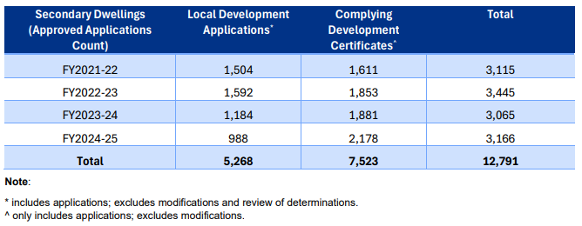

Dual occupancies
A dual occupancy refers to two dwellings located on a single lot, but does not include a secondary dwelling. The dwellings may be attached or detached. Dual occupancies are defined under the Standard Instrument as follows:
Dual occupancy means a dual occupancy (attached) or a dual occupancy (detached)
Dual occupancy (attached) means two dwellings on one lot of land that are attached to each other but does not include a secondary dwelling
Dual occupancy (detached) means two dwellings on one lot of land but does not include a secondary dwelling.
Unlike a secondary dwelling, a dual occupancy is not subject to size hierarchy requirements (where the second dwelling must be smaller than the principal dwelling). Both dwellings can be similar in size and status. Another key difference is that a dual occupancy can be subdivided into separate lots to create separate titles and can have separate ownership.
Dual occupancies are not a mandatory permissible use in any land zone under the Standard Instrument. Similar to secondary dwellings, councils can decide to add this use as 'permitted with consent' in particular zones by amending their LEP land use table.

Development approval pathways
During the inquiry, stakeholders addressed the differences between the development application approval pathway and obtaining approval under a Complying Development Certificate. This section sets out both approval pathways and how they differ from one another.

Complying development
Complying development is a fast-tracked development approval process for straightforward development that meets predetermined development standards. It combines planning and construction approvals which are progressed by an accredited private certifier or a local council. As complying development applications do not involve a merit assessment, non-discretionary development standards cannot be applied.
Non-discretionary, or non-refusal, standards provide consistency for matters like building heights, floor space ratio or lot size, which means that if the proposed development complies with the standard, the consent authority cannot refuse the application on the grounds of that standard.
Non-discretionary standards also mean that consent authorities cannot:
- take a standard into further consideration when determining the development application; and
- impose a condition of consent that has substantially the same effect as the standard.
Currently, secondary dwellings cannot be permitted under a complying development certificate in land zones RU1-RU6 and C1-C4. The below table provides a summary of secondary dwelling permissibility and development pathways in relevant rural and conservation zones.
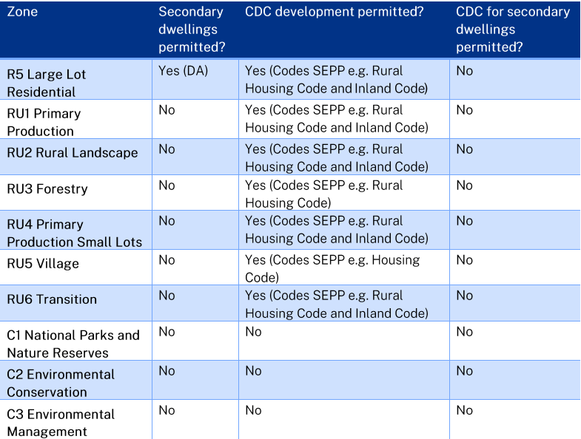
- Table of secondary dwelling permissibility and development pathways in relevant rural and conservation zones:

Development applications
A development application is necessary if a proposed development does not meet the specific requirements under a complying development certificate. In comparison to complying development, a development application is a formal, flexible submission to a local council for usually larger and more complex development. Development applications generally take longer to process as they often require more extensive documentation such as environmental impact assessments, shadow diagrams and heritage reports.
The Housing SEPP currently includes several non-discretionary standards for secondary dwellings subject to a development application that, if complied with, prevents the consent authority from requiring more onerous standards. These include minimum floor and site areas.
Development approval pathways in relation to second dwellings are addressed further in chapter 2.

The draft State Environmental Planning Policy (Housing) Amendment (Second Dwellings in Rural Zones) 2025
The draft 'State Environmental Planning Policy (Housing) Amendment (Second Dwellings in Rural Zones) 2025,' (Draft Model Instrument), tabled by the Hon John Ruddick MLC on 27 August 2025, proposes changes to existing planning instruments to liberalise the construction of secondary dwellings on zones RU1, RU2, RU4-RU6, C3 and C4 by:
- facilitating secondary dwellings on rural zoned land to support housing diversity, multi-generational living, and rural economic resilience
- permitting secondary dwellings as complying development in all rural zones
- removing requirements for secondary dwellings to be 'attached' to the principal dwelling
- eliminating size limits, allowing secondary dwellings to be equal to or larger than the principal dwelling and potentially function as the primary dwelling
- removing or relaxing distance restrictions
- allowing secondary dwellings on properties above a specified elevation or outside the 1-in-100-year flood zones
- enabling flexible legal title arrangements such as tenants in common, strata-like agreements without subdivision
- streamlining approvals through complying development and development application processes.
The Draft Model Instrument states that these proposed changes could be inserted into the Housing SEPP, the Codes SEPP or the Standard Instrument (within clause 5.5 or within a new mandatory clause). The proposed changes, once enacted and incorporated into the necessary planning instrument(s), would prevail over all inconsistent LEPs or SEPP provisions, per section 3.28 of the Environmental Planning and Assessment Act 1979. The reasons provided by stakeholders for why statewide reform is necessary are outlined in Chapter 2 of this report.
The Draft Model Instrument is available at Appendix 1.

Terminology
As discussed in above in paragraphs 1.12 and 1.22, the planning system provides definitions for both secondary dwellings and dual occupancies. The Draft Model Instrument provides a definition for 'second dwelling', which encompasses both secondary dwellings and dual occupancies.
The Law Society of New South Wales explained that adding a new definition for 'second dwelling' when there is an existing definition of 'secondary dwelling' should be avoided. Mr Alistair Knox, Chair, Environmental Planning and Development Committee, Law Society of New South Wales, stated that there are nuanced differences between the terms 'secondary dwellings,' 'rural workers dwellings' and 'dual occupancies,' and that there should be some consideration for how those existing definitions are intended to operate together. Mr Knox added, that while it is more of a legal consideration, 'sometimes confusion about definitions and entitlements on permissibility … can result in unintended environmental impacts'.
The term 'second dwelling' is used throughout this report to refer to both a secondary dwelling and dual occupancy.

- Key issues
This chapter begins by outlining the social and economic benefits of second dwellings in rural areas. It examines how easing restrictions and permitting second dwellings in rural and conservation zones could help to alleviate housing concerns, facilitate multigenerational living, support rural families and provide economic benefits. The chapter then discusses the challenges raised by stakeholders in relation to how second dwellings are assessed and permitted under the current planning system. To conclude, this chapter highlights local councils' concerns with easing restrictions on second dwellings.

The social and economic benefits of second dwellings in rural areas
Most stakeholders were in support of easing restrictions on second dwellings in rural areas. Stakeholders shared several social and economic benefits of permitting second dwellings in rural areas, including:
- alleviating housing concerns
- supporting multigenerational living and providing greater support to farming families
- economic benefits for families and local communities.

Alleviating housing concerns
The following section discusses factors identified as impacting housing concerns in rural regions of New South Wales. These factors include an increased demand for housing in rural communities and the gaps in medium to long-term accommodation available for those experiencing homelessness or needing emergency accommodation.
Addressing rental demand and homelessness
A key issue raised during the inquiry was increased rental demand in rural communities. Mr Michael Said, Assistant Director, Housing Industry Association, acknowledged that Australia is in 'the midst of a housing crisis' and stated that around 75,000 new homes in New South Wales need to be built each year to meet housing targets. Mr Said explained that secondary dwellings and dual occupancies are an opportunity to increase housing supply and provide more affordable rental accommodation.
Similarly, Mr Paul Riley, the Chair and Director of Lydia's Legacy Southern Highlands Homelessness highlighted that there was a significant overflow of people from urban areas trying to find a home in the Southern Highlands region. Mr Riley noted that this has further exacerbated the existing gap in medium to long-term accommodation available for those experiencing homelessness in the region.
To address homelessness in the region, Lydia's Legacy Southern Highlands Homelessness suggested that tiny homes be used to fill the gap in medium to long term accommodation. In their submission, they proposed a philanthropic model, suggesting that it is not entirely up to the government to build more homes. However, they noted that the existing Local Government (Manufactured Home Estates, Caravan Parks, Camping Grounds and Moveable Dwellings) Regulation 2021 hindered their ability to provide the tiny homes needed in their area.
Lydia's Legacy Southern Highlands Homelessness recommended the following sections be removed from the Local Government (Manufactured Home Estates, Caravan Parks, Camping Grounds and Moveable Dwellings) Regulation 2021:
- section 77(1)(a) exempts a development application (DA) for the installation of two caravans or tents, if they are not occupied for more than two consecutive days
- section 77(1)(b) exempts a DA of a tiny home, allowing for quicker development, if it is occupied 'by the owner or members of the owner's household'
- section 77(1)(c) exempts a DA if it is only 'occupied seasonally… in pastoral or agricultural operations'
- section 77(1)(d) exempts a DA if the tiny home is occupied by a displaced person due to a natural disaster, with the home to be removed within 2 years of installation.
Lydia's Legacy Southern Highlands Homelessness explained that these exemptions are actually more restrictive in their specificity. A proposed alternative to removing sections 77(1)(a)-(d) would be to add 'and homelessness' to the end of section 77(1)(d). Mr Riley explained that individuals should be able to stay in the tiny home indefinitely if 'escaping disaster'. Tiny homes are discussed further at paragraph 2.64.
Emergency accommodation
Stakeholders also suggested that second dwellings could be used as emergency accommodation. For example, Mr Bernd Jerzyna, Individual, Property Owner, stated: 'it's an asset that can be used for family or for emergency accommodation. Domestic violence, floods, bushfire and what have you—there will always be times when a small little place like that can come in handy to support somebody'.
Dr Andrew Rawson, Adjunct Associate Professor, Charles Sturt University, representing Better Planning Network suggested relaxing secondary dwelling controls in zones that require retreat from flood risk. Dr Rawson explained that a secondary dwelling could be permitted under a complying development certificate, allowing a landowner to move their dwelling to higher ground on the same lot.
To provide the committee with an example of where this has occurred, Dr Rawson explained that rules were 'very rapidly changed' in Eugowra to allow for pods to be placed in backyards to support people who were affected by flooding. He added that the local council has 'extended that across the shire to allow for smaller secondary dwellings in rural areas'.

Supporting multigenerational living and farming families
Another key reason provided by stakeholders in support of easing constraints and permitting second dwellings on rural zoned properties, was that it would provide support to farming families and facilitate multigenerational living. According to the evidence, allowing second dwellings would enable rural families to live closer together, to care for each other, learn from one another, and share in the responsibilities and significant demands of operating a working farm.
Caring responsibilities
Many participants supported permitting second dwellings on rural zoned properties to help them care for grandchildren or to accommodate elderly parents or grandparents. They highlighted the high costs of childcare and aged care, and emphasised the importance of enabling family members, who need additional support, to retain a degree of independence.
In her submission, Miss Emma Evans spoke of her elderly mother-in-law who lives alone on a large rural property. Miss Evans explained that due to her isolation, her mother-in-law 'suffers with debilitating anxiety and depression' and struggles with daily life. Miss Evans explained that if a second dwelling was permitted to be built on the land so that she and her family could live alongside her mother-in-law, it would provide the following benefits:
- Support and care: assistance with meals, property maintenance and companionship
- Mutual family support: allowing generations to live together strengthens family bonds
- Financial relief: living on family property would provide financial relief by alleviating the burden of having to pay a mortgage or rent.
This was supported by Mr Neil Mumme, Director, Progressive Project Solutions, who agreed that a second dwelling can 'provide elderly parents somewhere to live to keep them out of care' for as long as possible.
Aboriginal communities
New South Wales Aboriginal Land Council (NSWALC) stated that existing planning controls overlook the specific challenges faced by Aboriginal landowners. They advised that current planning regulations prevent Aboriginal communities from effectively using their land for housing projects.
Ms Kate Aubrey-Pioner, Manager, New South Wales Land Council (NSWALC), noted that the Aboriginal Land Rights Network holds over 3,600 properties that would be directly impacted by the reforms proposed. NSWALC suggested that reforms that enable second dwellings in rural areas would allow Aboriginal communities to 'deliver urgently needed housing on their lands'. This housing would help to address overcrowding and homelessness in the Aboriginal community.
NSWALC explained that current planning controls do not consider multigenerational housing arrangements. NSWALC highlighted that housing design is an important consideration for multigenerational living:
Overcrowding in Aboriginal communities is not simply a matter of supply, but of design. Well-designed, flexible housing strategies and adaptions can accommodate seasonal changes, extended kin, and aging in place, ensuring that cultural commitments to family and community are upheld.
NSWALC suggested that formal mechanisms be implemented to ensure shared decision-making, transparent communication, and ongoing collaboration between Local Aboriginal Land Councils, Aboriginal communities and the NSW Government. NSWALC recommended amendments be made to the State Environmental Planning Policy (Housing) 2021 (Housing SEPP) to enable flexible and streamlined approval pathways for second dwellings in rural areas.
Farm succession planning
Rural communities have traditionally been centred around families spanning several generations, collaboratively sharing work and land management responsibilities. NSW Farmers advised that 'when planning policies restrict families from building additional homes, it risks disrupting these generational bonds and jeopardising both succession planning and family well-being'.
In evidence, Mrs Rebecca Reardon, Vice President, NSW Farmers, explained that in order to maintain and carry out successful family succession planning, there needs to be the ability to build a second home on the property. In some cases, succession planning may require multiple generations to live together on one property. If there is only one main homestead on the property, then this will not be possible.
NSW Farmers explained that 'the passing down of farming skills, local knowledge and land stewardship through daily interactions between generations reinforces family resilience and cohesion'. They added that 'it exemplifies a family-centred social welfare model that lessens reliance on government and community services, while providing significant wellbeing and productivity advantages'. This sentiment was shared by other stakeholders.
Worker accommodation
Stakeholders, particularly those who are primary producers on large parcels of land, stated that in order to be able to maintain agriculture on their land, having a second dwelling is imperative to either maintain a family farming practice or to have additional workers onsite.
NSW Farmers provided the following reasons for needing workers to live onsite:
- Work health and safety: workers may need to work late nights, particularly during harvest, or start work in the early hours of the morning. Needing to travel across town at these times can be dangerous and pose significant work health and safety risks.
- Shared workload: where farm workers live onsite, the workload is able to be shared more evenly. This also allows the primary farmer or farm owner to take leave and travel away when needed.
- Immediate assistance: workers need to be on the farm to provide immediate and sometimes emergency assistance.
- Property protection: having workers live onsite can also help to deter theft, which 'is becoming an increasing issue'.
Mrs Reardon advised that 'members often report spending hundreds of thousands of dollars on houses in town for parents or employees, when a simple on-farm dwelling would be more affordable, practical and beneficial to the community'. She added that some members have 'lost skilled workers as there's no local accommodation'.

Economic benefits
Stakeholders identified the main economic benefits of permitting second dwellings on rural zones, both to rural families and rural and regional communities, including supplementary rental income for farmers, benefits to employment and the local building industry and impacts on tourism.
Supplementary income
Stakeholders spoke of the many factors that can impact the income and financial sustainability of a working farm and explained how a second dwelling could provide supplementary rental income to get farmers through challenging financial periods.
According to Mr John Colvin, Tweed Resident, 'farmers are more susceptible to sustained, sever business cycles than most occupations'. Drought, floods, disease, inflation, market fluctuations, currency exchange rates, interest rates and many other circumstances that do not affect workers in cities and towns affect farmers severely. As a result of this, many farmers stop farming or become bankrupt.
Mr Colvin advised that quite often farmers will have second jobs to help supplement their income and as they get older, or injured, they may live in poverty for short or long periods of time. If a farmer had a second dwelling, that dwelling could be rented out to provide supplementary income.
NSW Farmers stated that permitting farmers to build additional dwellings 'offers an important income source that enhances resilience'.
Employment and the local building industry
The committee heard that there would be significant benefits to the local building industry if more development was permitted in rural and regional areas.
Mr Michael Said, Assistant Director, Housing Industry Association, explained that relaxing restrictions on second dwellings will increase housing supply, and consequentially increase opportunities for work and employment within the construction industry. He added that due to the amount of 'red tape,' many builders are leaving the industry. Simplifying the process would encourage people to stay in the industry.
Mr Said did not have any concerns with respect to resourcing if there were to be a significant uplift in demand for construction due to second dwelling reform. He suggested that the industry 'would be able to adapt and pivot to construct the additional dwellings that might be required as a result of any changes that come into effect'.
Tourism
Some stakeholders spoke of the benefits that permitting second dwellings in rural zones would have on tourism. They also addressed the concept of agritourism, which involves operating tourism-related experiences on working farms to connect visitors directly with agricultural products, land and culture.
Mr Craig Huf, Chair, Far North Coast Branch, NSW Farmers Association, stated that the two greatest sources of income for the Tweed Shire are agriculture and tourism and because of this, there is a demand for short-term stay accommodation.

Key challenges in the current regulatory system for second dwellings
This section highlights the following challenges raised by stakeholders in relation to how second dwellings are assessed and permitted under the current planning system:
- the current restrictions imposed on secondary dwellings and dual occupancies
- inconsistencies in the way that second dwellings are managed across the state
- challenges with the development application process
- the restrictions imposed on other structures such as ancillary developments and outbuildings and the regulations for modular and tiny homes
- existing unauthorised structures and how these will be managed if the proposed reforms are enacted
- the ability to subdivide.

Restrictions on secondary dwellings and dual occupancies
This section provides a summary of the evidence received in relation to the restrictions that are currently imposed on both secondary dwellings and dual occupancies, which make it difficult for landowners to build second dwellings.
Secondary dwellings
Secondary dwellings are generally required to be smaller in floor area than the principal dwelling they are established in conjunction with. As discussed in chapter 1, clause 5.5 of the Standard Instrument is an optional clause that enables councils to set certain controls for secondary dwellings on land in rural zones. Under clause 5.5, local councils have the discretion to set both a maximum size on secondary dwellings and a minimum distance between the secondary and principal dwelling.
Mr Tom Loomes, Executive Director, Strategic Planning and Policy, Department of Planning, Housing and Infrastructure explained that, with regard to size or distance restrictions, councils are required to provide evidence as to how the construction of a secondary dwelling, if permitted, will not significantly impact the primary purpose of the zone, how they will limit that impact, and ensure that they are balancing the needs of that zone with the intent of providing more housing.
Size and distance limits for secondary dwellings can vary from council to council. Mr Neil Mumme, Director, Progressive Project Solutions, highlighted that 'most secondary dwellings are limited in size, under an LEP restriction, to 60 square metres'. He noted that this is a 'traditional granny flat size'.
Some stakeholders argued that dwelling size restrictions remain a significant barrier to providing practical housing solutions on rural properties. NSW Farmers explained that 'rural properties are often hundreds or thousands of hectares, yet dwellings are capped at sizes that reflect suburban contexts'. They argued that 'this creates absurd outcomes where a second dwelling is limited in scale even when the landholding could easily accommodate it without impacting neighbours or land use'. NSW Farmers were in support of housing reforms that 'recognise that farms often require larger dwellings to accommodate families, permanent workers or multigenerational households'.
The NSW Government advised that a secondary dwelling that exceeds maximum size controls would be defined as a dual occupancy. They stated that if secondary dwelling restrictions are removed, this would equate to permitting dual occupancies in rural and conservation zones. This could potentially increase residential densities in these zones, without prior strategic planning or consideration of necessary infrastructure provision.
Dual occupancies
The committee heard that while some LEPs permit dual occupancies in rural zones, they often require the second dwelling to be attached to the principal dwelling. Stakeholders raised the following three key issues in relation to this restriction.
- Where the second dwelling is required to be attached, this results in significant additional expenses. Satisfying the requirement to join the dwellings together, and ensuring they comply with the building code, can cost an extra $50,000 to $100,000.
- The restriction creates a lack of flexibility in terms of location for the second dwelling. This means that other areas on the property that may be more suitable, both from a practical and environmental standpoint, cannot be considered. Allowing more flexibility would help landowners avoid sensitive biodiversity areas and meet fire safety requirements more easily.
- There is reduced privacy and autonomy for those who wish to reside in the second dwelling. From a social perspective, having some level of separation between occupants of the principal dwelling and occupants of the second dwelling is preferred.
Ms Chris Cherry, Mayor, Tweed Shire Council provided a different perspective and stated that allowing a second dwelling to be detached from the principal dwelling may impact agricultural productivity and increase risks in emergency situations such as bushfires where people may need to be rescued from opposite ends of a lot.
This was also supported by Bathurst Regional Council who argued that 'any provision for additional dwellings must be explicitly constrained to the same allotment as the primary residence, without creating subdivision potential'. The council explained that this is 'essential to avoid fragmentation of rural landholdings, … which undermines agricultural viability, compromises landscape values, and generates cumulative pressure for further urban encroachment'.
Mr Tom Loomes, Executive Director, Strategic Planning and Policy, Department of Planning, Housing and Infrastructure, explained that there is often reluctance to allow detached second dwellings for several reasons. These include potential environmental impacts, loss of productive agricultural land if the dwelling is placed far from the main house, and increased exposure to hazards such as bushfire or flooding. The principal dwelling is usually best positioned to reduce these risks and avoid hazards. A detached dwelling located further away may not benefit from the same protections. However, Mr Loomes advised that the department recognises this as a key issue and that there is an opportunity to review the Housing SEPP to see if this could be better explained and managed.

Inconsistencies across the state
Many stakeholders expressed frustration at the inconsistent application of planning rules for second dwellings across the state. These stakeholders urged the committee to recommend consistent statewide provisions that make second dwellings a practical solution for rural property owners across New South Wales.
Mrs Rebecca Reardon, Vice President, NSW Farmers, stated that 'current planning rules are too metro-focused and inconsistent'. Mrs Reardon argued that there is a need for 'a uniform, statewide-based framework that permits second dwellings and possibly third dwellings as complying developments on rural zoning and conservation C3 and C4 lands without requiring subdivision'.
Others stated that given different local councils apply planning instruments in different ways, there are significant inconsistencies in the way that second dwelling applications are managed across the state. For example, Mr Michael Said, Assistant Director, Housing Industry Association, stated 'the issue is it's inconsistent ... some councils allow secondary dwellings; some don't. Some allow dual occupancies, but most of them are only if they are attached, so that creates significant issues…'.
Mr Troy Myers, General Manager, Urban City Group, agreed with this point and further stated that the proposed second dwelling reform, should be implemented by making changes to the Housing SEPP, Codes SEPP and the Standard Instrument. Urban City Group urged the committee to make a recommendation to streamline the approval process and ensure that councils and certifiers interpret the relevant SEPPs in a clear and consistent way. They added that 'updating the relevant SEPPs to permit detached dual occupancies and ancillary development on rural lots with up to two dwellings is a simple and achievable step that would have a meaningful and immediate impact'.
Mr Tom Loomes, Executive Director, Strategic Planning and Policy, Department of Planning, Housing and Infrastructure, stated that while there is currently a lot of flexibility in the Standard Instrument clauses and the optional clauses, they are not 'taken up consistently by councils where they could'. Mr Loomes advised that there is an opportunity for the department to be a 'bit more firm in certain zones where the risks in the land use conflicts could be managed'. He added that RU5 and RU6 zones may present a better opportunity than others. Mr Loomes concluded that the NSW Government should play a role in guiding councils to ensure that, when they are amending their LEPs, they consider 'what could be done to help ameliorate some of the significant housing stresses in their local areas'.
Some stakeholders were not supportive of having a blanket provision within a SEPP that relaxes restrictions on second dwellings. When asked whether a second dwelling should be allowed to be larger than the existing dwelling, Dr Andrew Rawson, Adjunct Associate Professor, Charles Sturt University, representing the Better Planning Network, stated: 'I think it comes back to being a case-by-case basis. I wouldn't be suggesting that there be a blanket ability to allow that sort of thing coming from a SEPP'. Dr Rawson argued that there is the risk that it could be abused and that 'the local council would be able to make the right call to make sure that that was done appropriately'.
A summary of local councils' evidence on this particular issue is provided at paragraph 2.84.

Challenges with the development application process
As discussed in chapter 1, complying development is a fast-tracked approval pathway for straightforward proposals that meet predetermined standards. By contrast, a development application is a more flexible and typically lengthier process for larger or more complex proposals. Some stakeholders critiqued the development application process and urged the committee to consider how the complying development pathway may be utilised for second dwellings.
The development application process
Many stakeholders were highly critical of the development application process. For example, Ms Rebecca Reardon, Vice President, NSW Farmers described the current development application process for second dwellings as 'very bureaucratic', 'unjustified', 'nonsensical' and 'not flexible'. She argued that there is a need to create a system that is friendly and provides exemptions for certain developments. She urged that 'we need to create an environment where farmers don't feel they have to go around the current system'.
Mr Troy Myers, General Manager, Urban City Group, also commented on the development application process and advised that it can take six to eighteen months to get a development application through and cost 'upwards of $25,000 per application'.
Mr Myers was supportive of having a list of criteria which could set minimum or maximum standards, (such as the size of the lot, size of the dwelling, footprint and connections to services), so that if the criteria is met, the development is approved.
The NSW Government advised that for secondary dwellings attached to, or separate from, the principal dwelling, the Housing SEPP relies on requirements for complying development under the Codes SEPP. The complying development pathway is currently only enabled in certain residential zones for secondary dwellings and does not apply to flood prone land or bushfire prone land. In evidence, Mr Tom Loomes, Executive Director, Strategic Planning and Policy, Department of Planning, Housing and Infrastructure, stated that the NSW Government could look at how it could be further expanded.
Complying development
Many stakeholders were in favour of changing the approval process of second dwellings from a development application process to approval under a complying development certificate.
Mr Michael Said, Assistant Director, Housing Industry Association, described complying development as a streamlined pathway, which provides certainty through clear, consistent standards that are set across New South Wales. Mr Said noted that without a complying development pathway, different local councils are setting their own individual standards, leading to significant inconsistencies in the way that second dwelling applications are managed across the state. Mr Said argued that a complying development certificate pathway would provide certainty, and deliver faster approvals, save time, money and would only serve to encourage that development. This approach was supported by many other stakeholders.
When asked if he could see any potential risks with the implementation of the rural housing reform, Mr Said responded that he did not believe there are any significant risks, and that if there are, they can be managed by existing controls within the current planning system:
I don't really see significant risk, to be honest. We already allow dwellings in rural areas. We allow attached dual occupancies and we allow secondary dwellings in some cases. I don't really see a significant risk. … Risks like flooding, bushfire and those sorts of controls—we already have planning frameworks in place to manage those risks, so there's no reason why those existing controls wouldn't already be able to deal with any additional risks that a secondary dwelling or a dual occupancy may create.
[…]
…I don't think there are issues around fragmentation. I don't see you're going to lose agricultural land or anything like that. We're not talking a large area in terms of what these dwellings are going to take in terms of size, so I don't see a significant risk. Or, if there are, I think those risks can be managed quite easily within the existing systems that we've got within the planning system.

Restrictions on other structures
During the inquiry, stakeholders commented on the regulations and restrictions that are currently imposed on outbuildings and ancillary developments, and modular and tiny homes.
Outbuildings and ancillary developments
In their submission, Urban City Group asked the committee to consider changes to the requirements for outbuildings and ancillary developments, such as sheds, swimming pools and carports under Part 3A of the State Environmental Planning Policy (Exempt and Complying Development Codes) 2008 (Codes SEPP). According to Urban City Group, ancillary development cannot be approved under a complying development certificate when there is more than one dwelling located on a property.
Mr Myers highlighted the costs involved in applying to have a shed or swimming pool added to a property that has a second dwelling stating 'it's significant. You're going from a one-stage process in complying [development] to a two-stage process … so you're doubling your costs there'. As a solution, Urban City Group recommended that detached dual occupancies and associated ancillary development should be included in Part 3D of the Codes SEPP.
Tiny and modular homes
Tiny homes are defined as a moveable dwelling on wheels (either on a trailer or registered as a caravan). As discussed above at paragraph 2.5, tiny homes are regulated under the Local Government (Manufactured Home Estates, Caravan Parks, Camping Grounds and Moveable Dwellings) Regulation 2021.
Mr Paul Riley, Chair and Director, Lydia's Legacy Southern Highlands Homelessness, advised that tiny homes are a great example of something that 'could be quite adequate for people for quite some time as well and why it would be a good solution to a longer term housing crisis'.
According to Lydia's Legacy Southern Highlands Homelessness, the provisions that apply to tiny homes under the regulations are 'unnecessarily obstructive'. For example, under section 77(1)(a), a proposed tiny home development exempts a development application if two tiny homes on a property are not occupied for more than two consecutive days, and more than 60 days in a year. Lydia's Legacy Southern Highlands Homelessness argued that the narrow scope of the exemptions, which results in many applications having to use the development application pathway, 'serves no tangible purpose'.
In relation to modular homes, Mr Neil Mumme, Director, Progressive Project Solutions, argued that the 'biggest handbrake' to development in New South Wales was not the Local Government Regulation 2021 but rather local councils' Development Control Plans (DCPs). Each individual council produces its Development Control Plan, drafted by one or two planners. These DCPs can vary in length, with some extending to hundreds of pages. The variation between councils' DCPs has led to requirements that are 'frequently excessive, inconsistent, [and] cost-prohibitive'.
To address the irregularity of DCPs across councils, Mr Mumme recommended that the NSW Government establish mandatory guidelines to ensure that DCPs across the state remain proportionate, practical and consistent with broader housing goals.
Mr Mumme also commented that a growing number of councils were refusing to accept applications for modular housing, as they believed they produced inferior or temporary housing.
Mr Mumme advised that under the Standard Instrument, the term 'building' excludes manufactured homes, movable dwellings (such as tiny homes) or associated structures. He argued that this is a contributing factor to councils across New South Wales not approving the construction of modular housing. Mr Mumme therefore recommended that the Department of Planning, Housing and Infrastructure revise the Standard Instrument to ensure modular and manufactured homes are included within the definition of 'dwelling' and 'building'.

Existing unauthorised structures
Stakeholders advised the committee that, due to the constraints placed on second dwellings and associated costs, some property owners start to look for alternatives that may not be legal.
Mr Peter Bennett, Lifetime Member, Tyalgum District Community Association, shared that a local councillor estimated there to be approximately 1,600 unapproved second dwellings in the Tweed Shire area. These include a range of dwellings including shipping containers, caravans, sheds and garages.
Mr Bennett recommended that, if the proposed rural housing reforms are enacted and the relevant changes are made to existing planning instruments, an amnesty should be granted to those who have existing unauthorised structures on their land. Mr Bennett added 'anybody wanting to sell their property now that's got a second dwelling on it has got a choice: Either they pull it down or else they hope that the person coming in is prepared to go ahead with an illegal dwelling on their property. The situation is really bad'.
When asked about granting amnesty to property owners with existing unauthorised second dwellings, and providing a transitional arrangement for these properties, Mr Tom Loomes, Executive Director, Strategic Planning and Policy, Department of Planning, Housing and Infrastructure, responded: 'I think we'd have to work it through … I think any approach to approval or for recognising those dwellings would need to be done through the lens of what risks that dwelling may face, whether it is environmental or it is hazard based'.

Subdivision
During the inquiry some stakeholders commented on subdivision. While some were supportive of reform that allows for a lot to be subdivided into two lots where the principal lot remains on one title and the second dwelling occupies another, others were less supportive.
The Tenants' Union of NSW highlighted that there is a great need for the delivery of more affordable housing in rural and regional communities and understood that one of the primary intentions of the proposed reform is to support multigenerational living. However, the union had concerns in relation to tenants' rights. They argued that if the changes proposed in the Draft Model Instrument are made 'it is highly likely that … some land owners may build or later convert a second home for the purpose of renting the house either on a short term basis for holiday makers or long term basis for tenants'.
In their submission, the Tenants' Union of NSW raised the following common issues for renters in multi-dwelling properties:
- Clarity of responsibility for rented premises: 'Poor fencing and unclear boundaries create issues on rural properties, making it difficult to determine which areas fall under the residential tenancy agreement. If more properties have multi-dwellings without subdivision, this could increase confusion'.
- Employee housing: policy changes could increase employee caretaker arrangements where housing is tied to employment. Although these arrangements are residential tenancy agreements with shorter termination notice periods, lack of landlord understanding or regulation can lead to serious breaches such as illegal lockouts.
- Affordability: there is a risk that multi-dwelling developments in high tourism areas will be used for short-term accommodation, limiting their benefit to rural New South Wales. In towns reliant on seasonal workers, existing shortages of affordable housing mean vulnerable workers may face increased risk of exploitation.
- Housing standard: 'some of the multi-dwellings currently in rural New South Wales have been built to a very low standard. Renters report issues with their homes being very cold in winter and very hot in summer. If changes are made to planning laws, it will be important to ensure that appropriate dwellings are built for the environment'.
- Utilities and services: utility provision and metering are a common source of disputes in multi-dwelling rental properties, particularly where utilities are not separately metered as required by the Residential Tenancies Act.
- Relationship with existing tenancies: on properties where the tenant is currently renting the only house on the property, they have exclusive possession of the whole premises. If the landowner is permitted to build multi-dwellings on the property, there is the possibility of disputes with existing tenants in relation to the loss of exclusive use of property and loss of access to parts of the property.
Mr Leo Patterson Ross, Chief Executive Officer, Tenants' Union of NSW, advised that where the second dwelling is rented out for income purposes, 'there needs to be more thought given to that legal relationship and the services being provided'. Mr Patterson Ross added 'we're concerned that too easily allowing secondary dwellings for rental use will exacerbate existing issues—particularly related to the management of properties, the infrastructure, the rights that tenants have—and will fail to deliver genuinely affordable and secure housing'.
Tenants' Union of NSW recommended that where the second dwelling is rented out to people outside of the family unit, for financial benefit, the property should be subdivided. They suggested that subdivision should alleviate some of the issues 'around boundaries, utilities, access and essential services and renting quality'.
Other stakeholders expressed different views towards subdivision. My Myers highlighted that the 'end goal' was not subdivision but rather allowing detached second dwellings. He stated: 'of course everyone would like to subdivide and make money out of selling the block of land these days. But the end goal is, like we said, multigenerational housing. It's a simple change'.
Mr Michael Said, Assistant Director, Housing Industry Association, shared a similar perspective stating that he did not believe subdivision to be 'necessary'. He explained that there are 'existing planning controls in terms of subdivision for existing properties within the LEPs. If the lot size with the secondary dwelling or the dual occupancy meets the minimum lot size that's required for that area, then subdivision would be able to be permitted anyway'.
To provide a different perspective, NSW Farmers stated that, in general terms, they are against subdivision. Mrs Rebecca Reardon, Vice President, NSW Farmers, suggested that: 'when you create subdivision, you're essentially scattering what might be lifestyle blocks in amongst primary production' and that this can create conflict between neighbouring landowners.
The NSW Government expressed concerned that permitting the subdivision of rural zoned land could result in permanent land fragmentation. They argued that the subdivision and fragmentation of rural zoned land could result in a shift in land use from primary production to rural residential uses, thereby diminishing the amount of land available for agriculture.

Local government perspective
Local councils had concerns with the proposal for statewide rules on second dwellings, and were generally not supportive of easing constraints and permitting second dwellings on rural and conservation zoned properties. This section outlines the following key concerns raised by local councils during the inquiry:
- the need for strategic planning and the importance of retaining local authority over the approval of second dwellings
- the potential impacts of second dwellings on agriculture and biodiversity
- the provision of infrastructure and services and, if the proposed reforms are enacted, how an increase in demand for infrastructure and services may be managed
- potential transitional arrangements and the monitoring of policy outcomes.

Strategic planning
Some stakeholders, and in particular, local councils, were concerned that introducing a statewide SEPP, and permitting a complying development certificate pathway for second dwellings, would prevent local councils from being able to apply a local understanding when assessing proposed development.
Ms Clare Aslanis, Team Leader, Strategic Planning, Camden Council, expressed the view that the proposed Draft Model Instrument does not 'allow for adequate opportunity for assessment of flooding, bushfire, biodiversity and native vegetation, our rural villages or heritage'. Ms Aslanis reflected that 'while we strive to achieve increase in housing supply and diversity, we believe that local planning will produce better planning outcomes for our community'.
Many local councils stated that they did not support a statewide approach and explained the need for local control. Mrs Katherine Vickery, Acting Director, Planning and Compliance, Hornsby Shire Council, advised that Hornsby Shire Council allows attached dual occupancies, secondary dwellings and rural workers' dwellings in rural zones, but not in conservation zones. Mrs Vickery explained that C3 and C4 zoned land typically applies to 'steep land, floodplains or native vegetation and are generally bushfire prone' and that 'a statewide approach would not consider such local place-based planning'.
The NSW Government agreed that housing in rural and conservation zones should be planned for, and managed at a local scale. They argued that 'introducing broad range legislative changes … risks exacerbating existing challenges relating to land use conflict, land fragmentation, biosecurity, biodiversity, and hazards'.

Impacts on agriculture and biodiversity
Some stakeholders raised concerns with respect to the impact that permitting second dwellings on rural and conservation zones may have on productive agricultural land, the rural landscape and biodiversity.
Ms Christiane Berlioz, Deputy Convenor, Better Planning Network, advised that it is important to look at the objectives of each zone and noted that there is a review of the state and federal environmental protection Acts 'which are actually weakening environmental protection'. Ms Berlioz argued that if conservation zones are opened up 'to very flexible regulations that allow an increase in development or subdivisions, I think, environmentally, that's going to have a dramatic effect'.
Ms Cherry, Mayor, Tweed Shire Council emphasised that the square meterage of a detached second dwelling is not the only area that will be impacted, but that the asset protection zone, access road, clearing and earthworks, as well as the edge effects need to be taken into consideration. Ms Cherry advised that when the council conducted its growth management housing strategy and asked the local community what was important to them, of the 639 submissions received, 348 were in relation to the protection of the natural environment and were concerned with the impact of increased housing on the natural area.
The need to protect the natural environment was shared by others during the inquiry, particularly from those representing local councils.
Similarly, The Law Society of New South Wales also raised concerns about the inclusion of C3 and C4 zones, as impacted zones, within the Draft Model Instrument. They advised that while they were supportive of a policy that facilitates the construction of second dwellings in rural zones, if implemented, the policy should only apply to RU1, RU2, RU4, RU5 and RU6 zones. They explained that given the objectives of zones C3 Environmental Management and C4 Environmental Living, they 'do not regard it as appropriate' for the proposed second dwelling reforms to apply to C3 and C4 zoned lands.

Impacts on infrastructure and services
Additional dwellings in rural and conservation zones increase demand for infrastructure such as sewer, water, power, telecommunications, waste facilities and roads. According to the NSW Government, the adequacy of existing local infrastructure for servicing second dwellings in rural and conservation zones is a matter for local councils.
Local councils advised that regional and rural councils face ongoing fiscal challenges related to infrastructure and service provision, and that these challenges are considered and reflected in local planning outcomes where needed.
Dr Andrew Rawson, representing Better Planning Network acknowledged that increasing housing in rural communities could go some way to help alleviate current housing concerns. However, he noted that 'this can only be achieved with significant investment in fundamental infrastructure such as transport links, telecommunications, health services, water supplies and sewerage facilities in regions where these facilities are historically poor'.
Mr Ed Paterson, Director, Strategies and Communities, Kiama Municipal Council, highlighted that secondary dwellings can create additional demand on council services. Mr Paterson stated that because council rates are applied to lots and parcels, rather than to individual dwellings, councils are unable to charge rates for those additional dwellings.
Stakeholders explained that these cost burdens are distributed across all ratepayers, increasing household costs and disadvantaging a large proportion of the community for the use and economic benefit of a few. Ms Chris Cherry, Mayor, Tweed Shire Council, recommended, that the rating system be changed 'to allow a multiplying factor for properties with a secondary dwelling or detached dual occupancy'.
Mr Tom Loomes, Executive Director, Strategic Planning and Policy, Department of Planning, Housing and Infrastructure, advised that since 2023-2024, the rate peg methodology used by the NSW Independent Pricing and Regulatory Tribunal (IPART) has included a population growth factor to ensure that each council’s general rating income can grow as the population grows. According to the department 'this adjustment has had a significant positive impact on the rate revenue available to councils in rural areas'.
Mr Loomes advised that this inquiry 'can be considered as part of deliberations to address rating anomalies and support councils in sustainably funding infrastructure and services in growing communities'.

Transitional arrangements and monitoring of policy outcomes
Some local councils asked the committee to consider potential transitional arrangements and how policy outcomes may be monitored should the proposed reforms come into effect.
Lismore City Council stated that their experience 'could inform pilot programs for broader reform' and agreed that 'monitoring should include environmental, agricultural and infrastructure impacts, housing and social outcomes, and community feedback'. Lismore City Council added that councils 'should be resourced to participate in evaluation and implementation'.
The issue of resources was also raised by Shoalhaven City Council, who stated that councils have 'limited resources to undertake monitoring of the policy outcomes should they eventuate'. They recommended that if a policy is introduced at state government level, then monitoring responsibilities should also rest with NSW Government agencies. In addition to this, ways in which councils can be assisted with any additional and enforcement burdens that may emerge from any associated reforms should be considered.
The NSW Government advised that any future policy reforms can be considered against the need for future transitional arrangements. They also stated that 'deferred commencement of legislation can also be considered for any future policy reforms, which may provide time for appropriate communication and education campaigns to be rolled out to industry and the community to adapt to any policy changes'.

Committee comment
The committee thanks the stakeholders, including individual landowners, farmers, local community groups, local councils, development and planning organisations and the NSW Government, who engaged with our inquiry and helped inform our understanding of the regulatory framework surrounding second dwellings in rural New South Wales.
The committee agrees that there is a clear need for second dwelling reform. We were concerned by the number of restrictions and regulations imposed on second dwellings and the challenges faced by landowners in obtaining council approval. According to the evidence, local councils apply planning instruments differently leading to inconsistences in the way that second dwelling applications are assessed and managed across the state.
The committee is of the view that existing planning controls and approval pathways for second dwellings are too restrictive, complex, time-consuming and costly. The evidence received highlighted the significant benefits that streamlining approval processes and easing restrictions on second dwellings in rural and conservation zones could have on communities. These include alleviating housing concerns, supporting multigenerational living and farming families and economic benefits to landowners and local communities.
There was strong support for consistent and simplified statewide planning provisions to ensure that second dwellings are a viable and practical option for rural landholders across New South Wales. The committee therefore recommends that amendments be made to the State Environmental Planning Policy (Housing) 2021 (Housing SEPP), the State Environmental Planning Policy (Exempt and Complying Development Codes) 2008 (Codes SEPP), the Standard Instrument (Local Environmental Plans) Order 2006, and any other necessary planning instruments and legislation, to liberalise the construction of second dwellings on rural and conservation zoned land by:
- permitting secondary dwellings and dual occupancies as complying development on land zones R5, RU1, RU2, RU4-RU6, and considering permitting them in zones C3 and C4 without requiring subdivision
- considering removing all requirements for any second dwelling to be attached to the principal dwelling
- considering removing or increasing size limits, allowing secondary dwellings and dual occupancies to be equal to or larger than the principal dwelling, and function as the principal dwelling
- allowing changes to set back and distance restrictions for secondary dwellings and dual occupancies
- considering allowing councils to permit secondary dwellings and detached dual occupancies on properties above a specified elevation, and outside 1-in-100-year flood zones
- considering permitting outbuildings and ancillary developments (such as sheds, swimming pools and carports) as complying development even when there is more than one dwelling located on the property.
In making the below recommendation, the committee clarifies that the reforms should not be used to permit more than two dwellings on a property. A property that elects to have a dual occupancy or a secondary dwelling should not have the other as a means by which to exceed the dual nature of the reforms proposed.

Recommendation
That the NSW Government consider amending the State Environmental Planning Policy (Housing) 2021 (Housing SEPP), the State Environmental Planning Policy (Exempt and Complying Development Codes) 2008 (Codes SEPP), the Standard Instrument (Local Environmental Plans) Order 2006, and any other necessary planning instruments and legislation, to liberalise the construction of second dwellings on rural and conservation zoned land by:
- permitting secondary dwellings and dual occupancies as complying development on land zones R5, RU1, RU2, RU4-RU6, and considering permitting them in zones C3 and C4 without requiring subdivision
- considering removing all requirements for any second dwelling to be attached to the principal dwelling
- considering removing or increasing size limits, allowing secondary dwellings and dual occupancies to be equal to or larger than the principal dwelling, and function as the principal dwelling
- allowing changes to set back and distance restrictions for secondary dwellings and dual occupancies
- considering allowing councils to permit secondary dwellings and detached dual occupancies on properties above a specified elevation, and outside 1-in-100-year flood zones
- considering permitting outbuildings and ancillary developments (such as sheds, swimming pools and carports) as complying development even when there is more than one dwelling located on the property.

The committee also recommends that the NSW Government publish and provide a toolkit to local councils to amend their Local Environmental Plans (LEP) to permit secondary dwellings in more zones subject to local strategic planning. This could include model LEP clauses and template.

Recommendation
That the NSW Government publish and provide a toolkit to local councils to amend their Local Environmental Plans (LEP) to permit secondary dwellings in more zones subject to local strategic planning. This could include model LEP clauses and template.

The committee considers the use of tiny homes to fill the gap in medium to long term accommodation to be a suitable option to address the issue of homelessness in rural communities.
The committee acknowledges the exemptions provided in section 77 of the Local Government (Manufactured Home Estates, Caravan Parks, Camping Grounds and Moveable Dwellings) Regulation 2021 that permits the installation of a moveable dwelling or associated structure without the requirement for council approval where the dwelling is used to accommodate a person who has been displaced as a result of a natural disaster. The committee is supportive of changes to the regulations that, if the dwelling is being used to accommodate a person who is experiencing homelessness, then the same exemption should apply in that circumstance, and the landowner should not have to seek approval from council.

Recommendation
That the NSW Government consider, with a view to amending, section 77 of the Local Government (Manufactured Home Estates, Caravan Parks, Camping Grounds and Moveable Dwellings) Regulation 2021, so that a moveable dwelling or associated structure on land used to accommodate a person experiencing homelessness applies under the exemptions.
The committee notes, that due to the constraints placed on second dwellings and associated costs, some property owners start to look for alternatives that may not be legal. The committee also notes with concern that property owners could be placing themselves and other occupants of these unauthorised structures in harm's way, especially if these unauthorised structures are located in flood or bushfire zones. We are concerned that, if the proposed reforms to second dwellings are enacted, then some landowners with existing unauthorised dwellings and structures may be prosecuted. The committee therefore recommends that, upon the enactment of any proposed rural housing reforms, the NSW Government grant amnesty to those who currently have existing unauthorised structures and dwellings on their land if they would be permissible under any new planning controls.

Recommendation
That, upon the enactment of any proposed rural housing reforms, the NSW Government grant amnesty to those who currently have existing unauthorised structures and dwellings on their land if they would be permissible under any new planning controls.
Finally, the committee acknowledges the concerns raised by local councils with respect to the reforms proposed. The reforms intend to relax restrictions on second dwellings, permitting more second dwellings on rural and conservation zoned land. This increase in dwellings, and therefore likely occupants, may lead to an increase in demand on existing infrastructure and services. The committee notes that there is currently no mechanism for local councils to increase rates or levy an additional charge on properties with an in-use second dwelling.
The committee therefore recommends that the demand on infrastructure and services in rural areas be reviewed two to three years after the proposed reforms have been enacted. If the demand on infrastructure and services has increased significantly as a result of second dwelling reform, the NSW Government should explore options to assist local councils in strengthening their infrastructure and services to manage the increase in demand. Reforms could include the development of an additional rate mechanism on properties with in-use second dwellings to address the impact on local road infrastructure.
As a matter of pre-emptive planning, the committee also recommends that the NSW Government require local councils to conduct an audit of all roads under their control and report on their existing condition.

Recommendation
That the NSW Government review the demand on infrastructure and services in rural areas two to three years after the proposed reforms have been enacted.
If the demand on infrastructure and services has increased significantly as a result of second dwelling reform, the NSW Government should explore options to assist local councils in strengthening their infrastructure and services to manage the increase in demand. Reforms could include the development of an additional rate mechanism on properties with in-use second dwellings to address the impact on local road infrastructure.
Recommendation
That the NSW Government require local councils to conduct an audit of all roads under their control and report on their existing condition.

- The Draft State Environmental Planning Policy (Housing) Amendment (Second Dwellings in Rural Zones) 2025

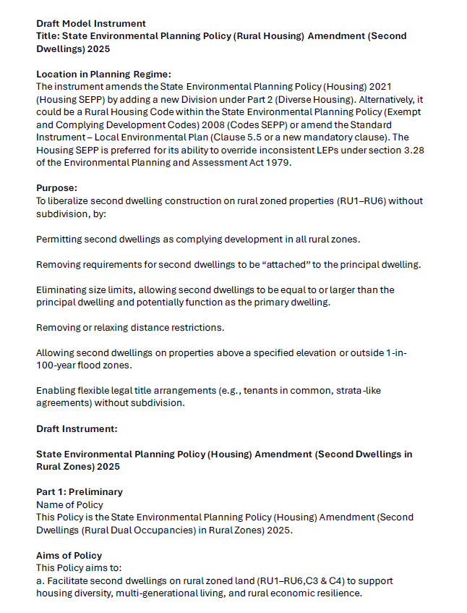

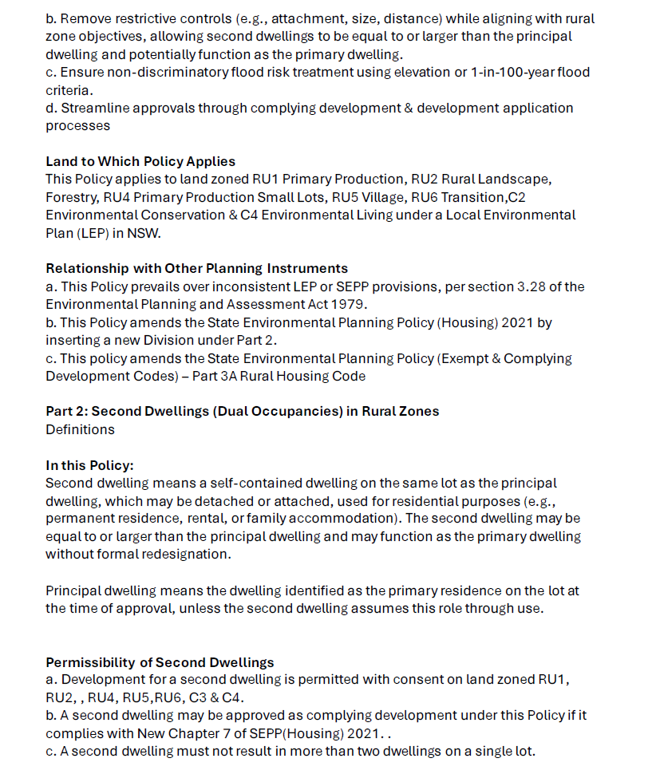

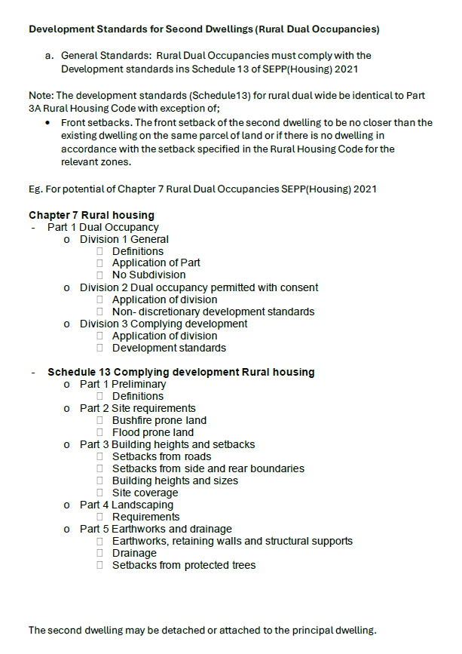

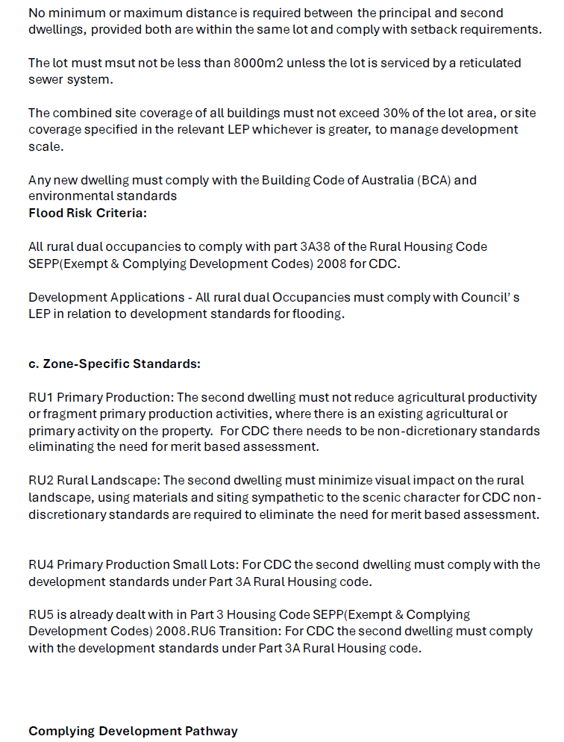

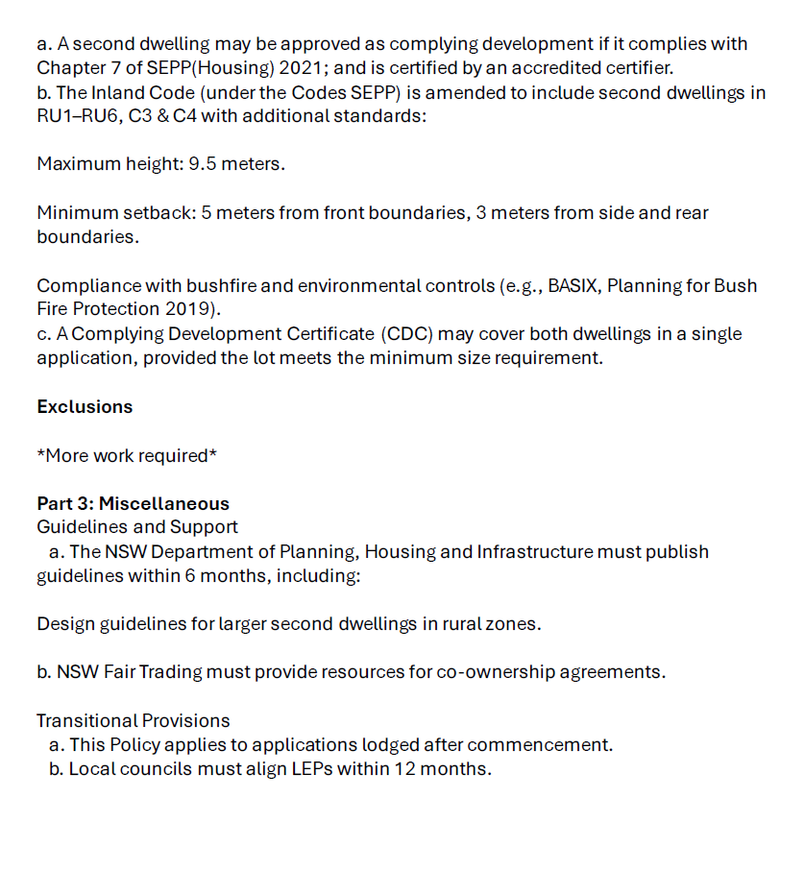

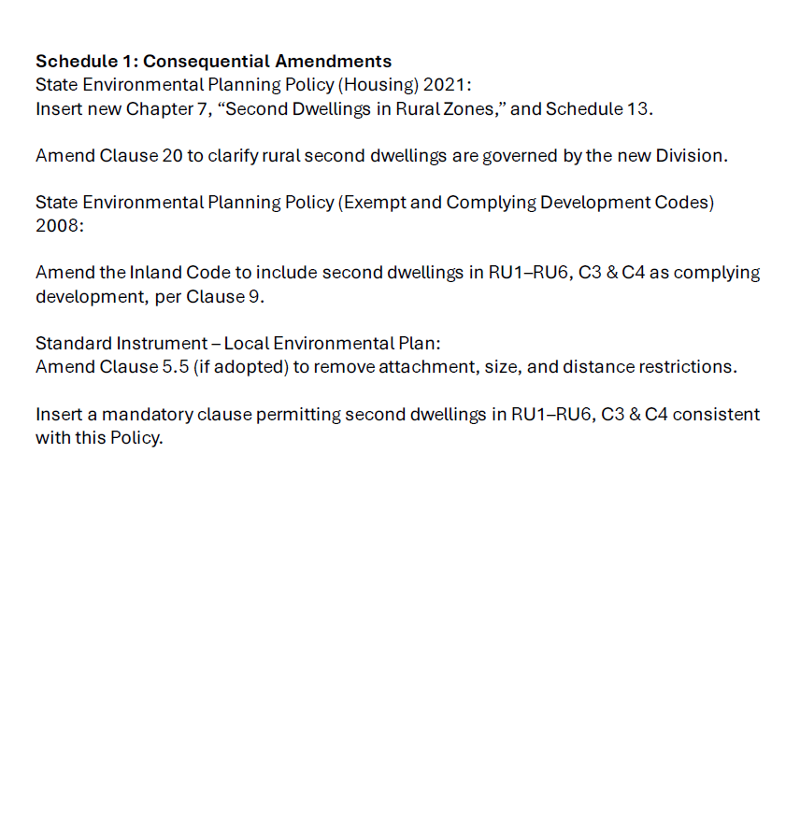

- Submissions
No. | Author
1 | Confidential
2 | Mr Malcolm E Pfeiffer
3 | Ms Margaret Houghton
4 | Name suppressed
5 | Confidential
6 | Mr Victor Pashkevich
7 | Mrs Sarah Gilard
8 | Name suppressed
9 | Name suppressed
10 | Mr Mark Awad
11 | Name suppressed
12 | Ms Jennifer Tomasetti
13 | Name suppressed
14 | Name suppressed
15 | Name suppressed
16 | Name suppressed
17 | Mr Lucas Ross
18 | Name suppressed
19 | Mr Troy Bray
20 | Name suppressed
21 | Name suppressed
22 | Marcus Grealy
23 | Miss Emma Evans
24 | Name suppressed
25 | Mr Stuart McConville
26 | Name suppressed
27 | Bathurst Regional Council
28 | Name suppressed
29 | Confidential
30 | Name suppressed
31 | Alan Hamilton
32 | Name suppressed
33 | Mrs Susan Wiedermann
34 | Name suppressed
35 | Name suppressed
36 | Wingecarribee Shire Council
37 | Samara King
38 | Mr William Everest
39 | Name suppressed
40 | Name suppressed
41 | Blue Mountains City Council
42 | Name suppressed
43 | Urban City Group
44 | Mr Bernd Jerzyna
45 | Name suppressed
46 | Name suppressed
47 | Name suppressed
48 | Name suppressed
49 | Mr Damien Jenkins
50 | Name suppressed
51 | Mr Neil Mumme
52 | NSW Farmers Association - Far North Coast Branch
53 | Tyalgum District Community Association
53a | Tyalgum District Community Association
54 | City of Newcastle
55 | Mrs Anna Gilliland
56 | Mrs Susan Cavill
57 | Confidential
58 | Albury City Council
59 | Mr Tony Proust
60 | Hornsby Shire Council
61 | Cootamundra-Gundagai Regional Council
62 | Ballina Shire Council
63 | Name suppressed
64 | Name suppressed
65 | Tenants' Union of NSW
66 | Name suppressed
67 | Name suppressed
68 | Mr Josh Slocombe
69 | Warren Shire Council
70 | Mr Philip Connor
71 | Lydia's Legacy Southern Highlands Homelessness
72 | Lake Macquarie City Council
73 | Name suppressed
74 | Mr David Wood
75 | Lismore City Council
76 | Ms Siobhan Withers
77 | Name suppressed
78 | Murray River Council
79 | Better Planning Network
80 | Bega Valley Shire Council
81 | Central NSW Joint Organisation (CNSWJO)
82 | Singleton Council
83 | Tweed Shire Council
84 | NSW Farmers
85 | Planning Institute Australia
86 | Kiama Municipal Council
87 | Name suppressed
88 | Housing Industry Association (HIA)
89 | Cessnock City Council
90 | Mr John Colvin
91 | The Hills Shire Council
92 | Camden Council
93 | Gunnedah Shire Council
94 | Goulburn Mulwaree Council
95 | Hawkesbury City Council
96 | Name suppressed
97 | Miss Imogen Myers
98 | Mr Aiden Sloman
99 | NSW Aboriginal Land Council (NSWALC)
100 | The Law Society of New South Wales
101 | Wollondilly Shire Council
101a | Wollondilly Shire Council
102 | Shellharbour City Council
103 | Local Government NSW
104 | Regional Australia Institute
105 | Shoalhaven City Council
106 | NSW Government
107 | Confidential
108 | Name suppressed
109 | Confidential
110 | Name suppressed
111 | Temora Shire Council
112 | Mr Jeremy Buckingham
113 | Mrs Katharina Wood
114 | Mrs Debbie McGavin
115 | Name suppressed
116 | Mrs Kimberly Hone
117 | Angela Beale
118 | Name suppressed
119 | Philip McCarroll
120 | Dimensions X
121 | Michael & Cathy Temple
122 | David Rohr, Ian Milner, Peter McLean & John Ardino
123 | Trevor Cain & Megan Mackay
124 | Barbara & Ron Junghans
125-196 | Short submissions – Public
197-278 | Short submissions – Name suppressed
279-290 | Short submissions - Confidential
291 | Name suppressed
292 | Name suppressed

- Witnesses at hearings
Date | Name | Position and Organisation
Monday 3 November 2025  Preston Stanley Room  Parliament House, Sydney | Mr Troy Myers | General Manager,  Urban City Group
 | Mr Leo Patterson Ross | Chief Executive Officer, Tenants' Union of NSW
 | Dr Andrew Rawson | Adjunct Associate Professor, Charles Sturt University
 | Ms Christiane Berlioz | Deputy Convenor,  Better Planning Network
 | Mr Michael Said | Assistant Director,  Housing Industry Association (HIA)
 | Ms Kate Aubrey-Poiner | Manager, Strategy and Policy, NSW Aboriginal Land Council (NSWALC)
 | Mrs Rebecca Reardon | Vice President, NSW Farmers
 | Miss Rhiannon Heath | Environmental Policy Advisor, NSW Farmers
 | Mrs Katherine Vickery | Acting Director, Planning and Compliance, Hornsby Shire Council
 | Mr Taylor Richardson | Team Leader, Strategic Land Use Planning, Hornsby Shire Council
 | Ms Clare Aslanis | Team Leader, Strategic Planning, Camden Council
 | Mr Josh Pownell | Manager Strategic Planning, Camden Council
 | Mr Ed Paterson | Director Strategies & Communities, Kiama Municipal Council
Monday 8 December 2025  Stars Room  Twin Towns Conference & Function Centre  Tweed Heads | Mr Craig Huf | Chair, NSW Farmers Association – Far North Coast Branch
 | Mr Peter Bennett | Lifetime Member,  Tyalgum District Community Association
 | Ms Chris Cherry | Mayor, Tweed Shire Council
 | Mrs Denise Galle | Director Planning & Regulation, Tweed Shire Council
 | Mr Mark Awad | Individual, Property Owner
 | Mr Bernd Jerzyna | Individual, Property Owner
 | Mr John Colvin | Individual, Tweed Resident
 | Ms Alice Withers | Individual, Property Owner
 | Mr Damien Jenkins | Farmer
 | Mrs Kimberly Hone | Individual
Tuesday 16 December 2025  Preston Stanley Room  Parliament House, Sydney | Mr Tom Loomes | Executive Director, Strategic Planning and Policy, Department of Planning, Housing and Infrastructure
 | Mr Alistair Knox | Chair of the Law Society’s Environmental Planning and Development Committee, Law Society of NSW
 | Ms Roslyn McCulloch | Deputy Chair of the Law Society’s Environmental Planning and Development Committee, Law Society of NSW
 | Mr Paul James Riley | Chair and Director, Lydia's Legacy Southern Highlands Homelessness
 | Dr Raymond Khoury | Director, Lydia's Legacy Southern Highlands Homelessness
 | Mr Neil Mumme | Director, Progressive Project Solutions
 | Mr Andrew Kearns | Manager Strategic Planning, Hawkesbury City Council

- Minutes
Minutes no. 1
Wednesday, 27 August 2025
Select Committee on Rural Housing and Second Dwellings Reform
Room 1254, Parliament House, Sydney at 1.02 pm
- Members present
Mr Ruddick, Chair
Mr D'Adam
Mr Fang
Mr Farlow
Ms Suvaal
- Apologies
Mr Buttigieg
- Election of Deputy Chair
The Chair called for nominations for the Deputy Chair.
Ms Suvaal moved: That Mr Farlow be elected Deputy Chair of the committee.
There being no further nominations, the Chair declared Mr Farlow elected Deputy Chair.
- Tabling of resolution establishing the committee
The committee noted the following resolution of the House establishing the committee, which reads as follows:
- That a select committee be established to inquire into and report on reforms to facilitate the construction of second dwellings in rural zones, and in particular:
  - planning instruments and development controls to facilitate the construction of second dwellings in rural zones in New South Wales, excluding Greater Sydney, with an emphasis on Outer Metropolitan Local Government Areas, and in particular the document entitled "State Environmental Planning Policy (Housing) Amendment (Second Dwellings in Rural Zones) 2025"
  - potential amendments to the State Environmental Planning Policy (Housing) 2021 (Housing SEPP), the State Environmental Planning Policy (Exempt and Complying Development Codes) 2008 (Codes SEPP), and related instruments to enable flexible, streamlined, and liberalised approval pathways for second dwellings on rural-zoned land
  - the benefits and risks of permitting second dwellings on RU1–RU6, C3 and C4 zoned lands, including via complying development
  - the suitable interaction between the Housing SEPP and/or Codes SEPP and provisions in Local Environmental Plans under section 3.28 of the Environmental Planning and Assessment Act 1979
  - the impact of removing restrictions on dwelling size, attachment, and internal lot distance and implications of enabling second dwellings to be larger than, or function as, the primary dwelling
  - the role of elevation criteria and 1-in-100-year flood mapping in determining permissibility and the use of performance-based solutions for flood-prone lands (e.g., elevation certification), other land-based hazards and environmental impacts
  - the interaction between second dwellings and potential impacts on rural activities and productive capacity of land for agriculture, including feasibility and implications of allowing second dwellings without subdivision
  - the use of non-discretionary, zone-specific development standards and their interaction with merit based assessment in complying pathways and legal frameworks for tenancy in common, co-ownership, and strata-like arrangements on rural land
  - mechanisms to streamline the development application and Complying Development Certificate (CDC) processes
  - the adequacy of existing infrastructure (e.g., sewerage, access roads) for servicing second dwellings and potential impacts of reforms on housing affordability, multigenerational living, and rural population growth
  - transitional arrangements and monitoring of policy outcomes, and
  - any other related matter.
- That, notwithstanding anything to the contrary in the standing orders, the committee consist of seven members comprising:
  - three government members
  - two opposition members, and
  - two crossbench members, being Mr Ruddick and Ms Higginson.
- That the Chair of the committee be Mr Ruddick and the Deputy Chair be elected at the first meeting.
- That, unless the committee decides otherwise:
  - all inquiries are to be advertised via social media, stakeholder emails and a media release distributed to all media outlets in New South Wales
  - submissions to inquiries are to be published, subject to the Committee Clerk checking for confidentiality and adverse mention and, where those issues arise, bringing them to the attention of the committee for consideration
  - attachments to submissions are to remain confidential
  - the Chair’s proposed witness list is to be circulated to provide members with an opportunity to amend the list, with the witness list agreed to by email, unless a member requests the Chair to convene a meeting to resolve any disagreement
  - the sequence of questions to be asked at hearings alternate between Opposition, crossbench and Government members, in that order, with equal time allocated to each
  - transcripts of evidence taken at public hearings are to be published
  - supplementary questions are to be lodged with the Committee Clerk within two business days following the receipt of the hearing transcript, with witnesses requested to return answers to questions on notice and supplementary questions within 21 calendar days of the date on which questions are forwarded to the witness
  - answers to questions on notice and supplementary questions are to be published, subject to the Committee Clerk checking for confidentiality and adverse mention and, where those issues arise, bringing them to the attention of the committee for consideration, and
  - media statements on behalf of the committee are to be made only by the Chair.
- That the committee report by 13 February 2026.
- Tabling of State Environmental Planning Policy (Housing) Amendment (Second Dwellings in Rural Zones) 2025
The Chair tabled the following document:
- 'State Environmental Planning Policy (Housing) Amendment (Second Dwellings in Rural Zones) 2025'.
Resolved, on the motion of Mr Farlow: That the committee accept and publish the document tabled by the Chair entitled 'State Environmental Planning Policy (Housing) Amendment (Second Dwellings in Rural Zones) 2025.'
- Conduct of committee proceedings
  - Media
Committee noted the Broadcast of Proceedings resolution (as amended by the Legislative Council on 19 October 2022), in particular the provisions relating to the filming, broadcasting, rebroadcasting and photography of committee proceedings, including:
- That unless resolved otherwise by a committee, this House authorises:
  - the filming, broadcasting and photography of members and witnesses in committee proceedings:
    - by representatives of media organisations, including from around the committee meeting table,
    - by any member of the public, from the position of the audience, and
  - the rebroadcasting of committee proceedings on the Legislative Council and Parliament's social media channels.
- Conduct of inquiry into rural housing and second dwellings reform
  - Proposed timeline
Resolved, on the motion of Mr Fang: That the committee adopt the following timeline for the administration of the inquiry:
- Submissions to close on Friday 10 October 2025
- Committee to conduct two or more hearings/site visits in November 2025 and December 2025, subject to member availability, with locations to be determined by the committee following the receipt of submissions
- The report deliberative to be held in early February 2026
- The committee to report by 13 February 2026.
  - Closing date for submissions
Resolved, on the motion of Ms Suvaal: That the closing date for submissions be Friday, 10 October 2025.
  - Stakeholder list
Resolved, on the motion of Ms Suvaal: That
- the secretariat circulate to members the Chair's proposed list of stakeholders to be invited to make a submission
- members have two days from when the Chair's proposed list is circulated to make amendments or nominate additional stakeholders
- the committee agree to the stakeholder list by email, unless a meeting of the committee is required to resolve any disagreement.
  - Approach to submissions
Resolved, on the motion of Mr D'Adam: That, to enable significant efficiencies for members and the secretariat while maintaining the integrity of how submissions are treated, in the event that 50 or more individual submissions are received, the committee may adopt the following approach to processing short submissions:
- All submissions from individuals 250 words or less in length will:
  - have an individual submission number, and be published with the author's name or as name suppressed, or kept confidential, according to the author's request
  - be reviewed by the secretariat for adverse mention and sensitive/identifying information, in accordance with practice
  - be channelled into one single document to be published on the inquiry website
- All other submissions will be processed and published as normal.
  - Sub-committee
Resolved, on the motion of Mr D'Adam: That, subject to advice from the secretariat, the committee authorises the Chair to move a motion in the House to amend the resolution establishing the committee to allow for the appointment of a sub-committee.
- Adjournment
The committee adjourned at 1.21 pm, sine die.

Alice Wood
Committee Clerk

Minutes no. 2
Monday 3 November 2025
Select Committee on Rural Housing and Second Dwellings Reform
Preston Stanley Room, Parliament House, Sydney at 9.46 am
- Members present
Mr Ruddick, Chair
Mr Farlow, Deputy Chair
Mr Buttigieg (via videoconference)
Mr D'Adam (via videoconference)
Mr Fang
Ms Suvaal
- Previous minutes
Resolved, on the motion of Ms Suvaal: That draft minutes no. 1 be confirmed.
- Correspondence
The committee noted the following item of correspondence:
Received
- 15 September 2025 – Email from Mrs Camille Awad and Mr Mark Awad, to the secretariat, requesting that the scope of the terms of reference be expanded to include restrictions that exist around the granting of dwelling entitlements on certain rural properties.
- Inquiry into rural housing and second dwellings reform
  - Public submissions
The committee noted that the following submissions were published by the committee clerk under the authorisation of the resolutions appointing the committee: submission nos. 2, 3, 6, 7, 10, 12, 17, 19, 22, 23, 25, 27, 31, 33, 36-38, 41, 43, 49, 51-56, 58-62, 65, 68, 70-72, 74-76, 78-86, 88-92, 99-100, 102-103 and 106.
  - Name suppressed submissions
Resolved, on the motion of Mr Fang: That That the committee keep the following information confidential, as per the request of the authors: names and/or identifying and sensitive information in submission nos. 4, 8, 9, 11, 13-16, 18, 20, 21, 24, 26, 28, 30, 32, 34, 35, 39, 40, 42, 45-48, 50, 63, 64, 73, 77 and 87.
  - Confidential submissions
Resolved, on the motion of Ms Suvaal: That the committee keep submission nos. 1, 5, 29 and 57 confidential, as per the request of the authors.
  - Further committee activity
Resolved, on the motion of Mr Fang: That the committee conduct a public hearing in Tweed Shire on Monday 8 December 2025.
Resolved, on the motion of Mr D'Adam: That the committee conduct a site visit in the Hawkesbury region and potentially conduct a short hearing at Parliament House, Sydney on Monday 24 November 2025.
  - Public hearing
Sequence of questions
Resolved, on the motion of Ms Suvaal: That the allocation of questions to be asked at the hearing be left in the hands of the Chair.
Witnesses, the public and the media were admitted.
The Chair made an opening statement regarding the broadcasting of the proceedings and other matters.
The following witness was sworn and examined:
- Mr Troy Myers, General Manager, Urban City Group.
The evidence concluded and the witness withdrew.
The following witness was sworn and examined:
- Mr Leo Patterson Ross, Chief Executive Officer, Tenants' Union of NSW.
The evidence concluded and the witness withdrew.
The following witnesses were sworn and examined:
- Dr Andrew Rawson, Adjunct Associate Professor, Charles Sturt University
- Ms Christiane Berlioz, Deputy Convenor, Better Planning Network.
The evidence concluded and the witnesses withdrew.
The following witness was sworn and examined:
- Mr Michael Said, Assistant Director, Housing Industry Association (HIA).
The evidence concluded and the witness withdrew.
The following witness was sworn and examined:
- Ms Kate Aubrey-Poiner, Manager, Strategy and Policy, NSW Aboriginal Land Council (NSWALC) (via videoconference).
The evidence concluded and the witness withdrew.
The following witnesses were sworn and examined:
- Mrs Rebecca Reardon, Vice President, NSW Farmers
- Miss Rhiannon Heath, Environmental Policy Advisor, NSW Farmers.
The evidence concluded and the witnesses withdrew.
The following witnesses were sworn and examined:
- Mrs Katherine Vickery, Acting Director, Planning and Compliance, Hornsby Shire Council
- Mr Taylor Richardson, Team Leader, Strategic Land Use Planning, Hornsby Shire Council
- Ms Clare Aslanis, Team Leader Strategic Planning, Camden Council
- Mr Josh Pownell, Manager Strategic Planning, Camden Council
- Mr Ed Paterson, Director Strategies & Communities, Kiama Municipal Council.
The evidence concluded and the witnesses withdrew.
The public hearing concluded at 3.15 pm.
The public and the media withdrew.
- Adjournment
The committee adjourned at 3.15 pm, until Monday 24 November 2025 (public hearing).

Alice Wood
Committee Clerk

Minutes no. 3
Monday 8 December 2025
Select Committee on Rural Housing and Second Dwellings Reform
Stars Room, Twin Towns Conference and Function Centre, Tweed Heads at 11.25 am

- Members present
Mr Ruddick, Chair
Mr Farlow, Deputy Chair
Mr Fang
Ms Higginson
Ms Suvaal
- Apologies
Mr D'Adam
- Previous minutes
Resolved, on the motion of Mr Farlow: That draft minutes no. 2 be confirmed.
- Correspondence
The committee noted the following items of correspondence:
Received
- 28 October 2025 – Email from Ms Michelle Olsen, Executive Assistant to Executive Director Planning and Environment, Shellharbour City Council to the secretariat, declining the invitation to attend the hearing at Parliament House, Sydney on Monday 3 November 2025
- 28 October 2025 – Email from Mr Simon Porter, Acting Manager – City Planning, Blue Mountains City Council to the secretariat, declining the invitation to attend the hearing at Parliament House, Sydney on Monday 3 November 2025
- 29 October 2025 – Email from Mr Nicholas Carlton, Manager – Forward Planning, The Hills Shire Council to the secretariat, declining the invitation to attend the hearing at Parliament House, Sydney on Monday 3 November 2025
- 29 October 2025 – Email from Ms Gabrielle Lea, Senior Policy Lawyer, The Law Society of New South Wales to the secretariat, advising that they are unable to attend the hearing at Parliament House, Sydney on Monday 3 November 2025
- 30 October 2025 – Email from Ms Melanie Cariss, Manager, Parliamentary and Government Services, Department of Planning, Housing and Infrastructure to the secretariat, requesting that the hearing on Monday 3 November 2025 be postponed by two weeks so that the Department can attend and give evidence at a later date
- 27 November 2025 – Email from Mrs Susan Wiedermann to the secretariat, declining the invitation to attend the hearing in Tweed Heads on Monday 8 December 2025
- 28 November 2025 – Email from Mr Alan Hamilton to the secretariat, declining the invitation to attend the hearing in Tweed Heads on Monday 8 December 2025
- 3 December 2025 – Email from Mr John Bedin c/- Mr William Everest to the secretariat, declining the invitation to attend the hearing in Tweed Heads on Monday 8 December 2025.
- Inquiry into rural housing and second dwellings reform
  - Public submissions
The committee noted that the following submissions were published by the committee clerk under the authorisation of the resolutions appointing the committee: submission nos. 44, 69, 93-95, 97-98, 101, 104, and 105.
  - Partially confidential submissions
Resolved, on the motion of Mr Fang: That the committee keep the following information confidential, as per the request of the authors: names and/or identifying and sensitive information in submission nos. 66-67, 96, 108 and 110.
  - Confidential submissions
Resolved, on the motion of Mr Farlow: That the committee keep submission nos. 107 and 109 confidential, as per the request of the author.
  - Public hearing
Sequence of questions
Resolved, on the motion of Ms Suvaal: That the allocation of questions to be asked at the hearing be left in the hands of the Chair.
Witnesses, the public and the media were admitted.
The Chair made an opening statement regarding the broadcasting of the proceedings and other matters.
The following witnesses were sworn and examined:
- Mr Craig Huf, Chair, NSW Farmers Association – Far North Coast Branch
- Mr Peter Bennett, Lifetime Member, Tyalgum District Community Association.
Mr Bennett tendered the following document:
- 'What land is affected by this strategy?' Rural Land Strategy 2019 - 2036, Tweed Shire Council.
The evidence concluded and the witnesses withdrew.
The following witnesses were sworn and examined:
- Ms Chris Cherry, Mayor, Tweed Shire Council
- Mrs Denise Galle, Director Planning and Regulation, Tweed Shire Council.
The evidence concluded and the witnesses withdrew.
The following witnesses were sworn and examined:
- Mr Mark Awad, Individual, Property Owner
- Mr Bernd Jerzyna, Individual, Property Owner.
Mr Awad tendered the following document:
- 'Ballina Online Mapping,' Ballina Shire Council.
The evidence concluded and the witnesses withdrew.
The following witnesses were sworn and examined:
- Mr John Colvin, Tweed Resident
- Ms Alice Withers, Individual, Property Owner.
The evidence concluded and the witnesses withdrew.
The following witnesses were sworn and examined:
- Mr Damien Jenkins, Farmer
- Mrs Kimberly Hone, Individual.
Mr Jenkins tendered the following documents:
- 'Submission for Rural Housing and Second Dwelling Reform by Damien Jenkins', 8 December 2025
- 'Summary of Development Application and Process by Mr Josh Townsend, Senior Town Planner with Planit Consulting'
- 'Managing Private Land in the Tweed', Tweed Shire Council
- 'Rural Land Strategy – Map 2'.
The evidence concluded and the witnesses withdrew.
The public hearing concluded at 3.32 pm.
The public and the media withdrew.
- Tendered documents
Resolved, on the motion of Ms Suvaal: That the committee accept and publish the following documents tendered during the public hearing:
- 'What land is affected by this strategy?' Rural Land Strategy 2019 - 2036, Tweed Shire Council, tendered by Mr Bennett
- 'Ballina Online Mapping,' Ballina Shire Council, tendered by Mr Awad
- 'Submission for Rural Housing and Second Dwelling Reform by Damien Jenkins', 8 December 2025, tendered by Mr Jenkins
- 'Managing Private Land in the Tweed' Tweed Shire Council, tendered by Mr Damien Jenkins
- 'Rural Land Strategy – Map 2,' tendered by Mr Jenkins.
Resolved, on the motion of Ms Suvaal: That the committee accept and publish the following document tendered during the public hearing, with the exception of the address to which the development application is in relation to:
- 'Summary of Development Application and Process by Mr Josh Townsend, Senior Town Planner with Planit Consulting' tendered by Mr Jenkins.
- Adjournment
The committee adjourned at 3.35 pm, until Tuesday 16 December 2025, Preston Stanley Room, Parliament House, Sydney (public hearing and site visit in Hawkesbury).

Alice Wood
Committee Clerk

Minutes no. 4
Tuesday 16 December 2025
Select Committee on Rural Housing and Second Dwellings Reform
Preston Stanley Room, Parliament House, Sydney at 9.00 am
- Members present
Mr Ruddick, Chair
Mr Farlow, Deputy Chair
Mr D'Adam (via videoconference)
Mr Fang (via videoconference)
Ms Higginson
Ms Suvaal
- Previous minutes
Resolved, on the motion of Ms Suvaal: That draft minutes no. 3 be confirmed.
- Correspondence
The committee noted the following item of correspondence:
Received
- 5 December 2025 – Email from Mr Damian Thomas, Director Advocacy, Local Government NSW to the secretariat, declining the invitation to attend the hearing at Parliament House, Sydney on Tuesday 16 December 2025.
- Inquiry into rural housing and second dwellings reform
  - Public submissions
The committee noted that the following submissions were published by the committee clerk under the authorisation of the resolutions appointing the committee: submission nos. 111-114, 116-117 and 119-124.
  - Partially confidential submissions
Resolved, on the motion of Mr D'Adam: That the committee keep the following information confidential, as per the request of the author: names and/or identifying and sensitive information in submissions nos. 115 and 118.
  - Reporting date
Resolved, on the motion of Ms Higginson: That the committee seek an extension from the House to extend the reporting date until 31 March 2026.
  - Due date for post-hearing responses
Resolved, on the motion of Ms Higginson: That the due date of post-hearing responses, including answers to questions on notice, answers to supplementary questions, and transcript corrections and clarifications, for the hearings on 8 December 2025 and 16 December 2025, be Friday 23 January 2026.
  - Short public submissions
The committee noted that the following short submissions were published by the committee clerk under the authorisation of the resolutions appointing the committee: submission nos. 125-196.
  - Short partially confidential submissions
Resolved, on the motion of Ms Suvaal: That the committee keep the following information confidential, as per the request of the author: names and/or identifying and sensitive information in submissions nos. 197-278.
  - Short confidential submissions
Resolved, on the motion of Mr D'Adam: That the committee keep short submission nos. 279-290 confidential, as per the request of the author.
  - Answers to questions on notice
The committee noted that the following answers to questions on notice were published under the authorisation of the resolution appointing the committee:
- answers to questions on notice from Ms Kate Aubrey-Poiner, Manager, Strategy and Policy, NSW Aboriginal Land Council (NSWALC), received 19 November 2025
- answers to questions on notice from Mrs Katherine Vickery, Acting Director, Planning and Compliance, Hornsby Shire Council, received 24 November 2025
- answers to questions on notice from Ms Clare Aslanis, Team Leader - Heritage, Precincts and Rural, Camden Council, received 27 November 2025
- answers to questions on notice from Ms Deb Boles, Executive Assistant to Mr Ed Paterson, Director, Strategies, & Communities, Kiama Municipal Council, received 28 November 2025
- answers to questions on notice from Mr Leo Patterson Ross, Chief Executive Officer, Tenants' Union of NSW, received 28 November 2025.
  - Public hearing
Sequence of questions
Resolved, on the motion of Ms Suvaal: That the allocation of questions to be asked at the hearing be left in the hands of the Chair.
Witnesses, the public and the media were admitted.
The Chair made an opening statement regarding the broadcasting of the proceedings and other matters.
The following witness was sworn and examined:
- Mr Tom Loomes, Executive Director, Strategic Planning and Policy, Department of Planning, Housing and Infrastructure.
The evidence concluded and the witness withdrew.
The following witnesses were sworn and examined:
- Mr Alistair Knox, Chair of the Law Society’s Environmental Planning and Development Committee, Law Society of NSW
- Ms Roslyn McCulloch, Deputy Chair of the Law Society’s Environmental Planning and Development Committee, Law Society of NSW.
The evidence concluded and the witnesses withdrew.
The following witnesses were sworn and examined:
- Mr Paul James Riley, Chair and Director, Lydia's Legacy Southern Highlands Homelessness
- Dr Raymond Khoury, Director, Lydia's Legacy Southern Highlands Homelessness.
The evidence concluded and the witnesses withdrew.
The following witness was sworn and examined:
- Mr Neil Mumme, Director, Progressive Project Solutions.
The evidence concluded and the witness withdrew.
The following witness was sworn and examined:
- Mr Andrew Kearns, Manager Strategic Planning, Hawkesbury City Council.
The evidence concluded and the witness withdrew.
The public hearing concluded at 12.08 pm.
The public and the media withdrew.
Mr Fang left the meeting.
Mr D'Adam left the meeting.
- Site visits
The committee attended three sites in the Hawkesbury region and were accompanied by the following:
- Mr Troy Myers, General Manager, Urban City Group
- Councillor Les Sheather, Mayor, Hawkesbury City Council
- Councillor Nathan Zamprogno, Hawkesbury City Council.
Mr Myers tendered the following documents:
- 'Site meeting notes - Location 1,' Urban City Planning, 16 December 2025
- 'Site meeting notes - Location 2,' Urban City Planning, 16 December 2025
- 'Site meeting notes - Location 3,' Urban City Planning, 16 December 2025.
- Adjournment
The committee adjourned at 6.20 pm, sine die.

Alice Wood
Committee Clerk

Draft minutes no. 5
Monday 23 March 2026
Select Committee on Rural Housing and Second Dwellings Reform
Room 814, Parliament House, Sydney at 1.02 pm
- Members present
Mr Ruddick, Chair
Mr Farlow, Deputy Chair
Mr Buttigieg (via videoconference)
Mr D'Adam (via videoconference)
Mr Fang
Ms Higginson
Ms Suvaal
- Previous minutes
Resolved, on the motion of Ms Suvaal: That draft minutes no. 4 be confirmed.
- Correspondence
The committee noted the following items of correspondence:
Received
- 21 November 2025 – Email from the Office of Mr John Ruddick MLC, to the secretariat, containing a submission provided by Ms Jennifer Harris, for the inquiry into rural housing and second dwellings reform
- 10 January 2026 – Letter from Mr Mark Awad, Property Owner, to the secretariat, providing additional information to the committee for the inquiry into rural housing and second dwellings reform
- 6 and 8 February 2026 – Emails from Mr Gerard Payne, to the secretariat, providing information to the committee for the inquiry into rural housing and second dwellings reform
- 9 February 2026 – Email from Mr Timothy Lloyd, to the secretariat, providing information to the committee for the inquiry into rural housing and second dwellings reform
- 14 February 2026 – Email from Mr Ethan Martin, to the secretariat, providing information to the committee for the inquiry into rural housing and second dwellings reform
- 28 February 2026 – Email from Mr Tim Masters, to the secretariat, providing information to the committee for the inquiry into rural housing and second dwellings reform.
Resolved, on the motion of Mr Farlow: That the committee keep the email from Mr Gerard Payne, dated 6 February 2026 confidential, as per the recommendation of the secretariat, as it contains identifying information and potential adverse mention.
Resolved, on the motion of Ms Suvaal: That the committee keep the email from Mr Tim Masters, dated 28 February 2026 confidential, as per the request of the author.

- Inquiry into rural housing and second dwellings reform
  - Documents tendered at site visit
Resolved, on the motion of Mr Farlow: That the committee keep the following documents tendered by Mr Troy Myers, General Manager, Urban City Group, at the Hawkesbury site visit on 16 December 2025 confidential as per the recommendation of the secretariat, as they contain identifying information:
- 'Site meeting notes - Location 1,' Urban City Planning, 16 December 2025
- 'Site meeting notes - Location 2,' Urban City Planning, 16 December 2025
- 'Site meeting notes - Location 3,' Urban City Planning, 16 December 2025.
  - Public submission
The committee noted that the following supplementary submission was published by the committee clerk under the authorisation of the resolution appointing the committee: supplementary submission no. 53a.
  - Partially confidential submissions
The committee noted that the following submissions were published by the committee clerk under the authorisation of the resolution appointing the committee: 291 and 292.
  - Answers to questions on notice and supplementary questions and attachments
The committee noted that the following answers to questions on notice and supplementary questions were published under the authorisation of the resolution appointing the committee:
- answers to questions on notice from Mr Tom Loomes, Executive Director, Strategic Planning and Policy, Department of Planning, Housing and Infrastructure, received on 20 January 2026
- answers to questions on notice and supplementary questions from Tweed Shire Council, received on 19 February 2026
- attachment to answers to supplementary questions titled 'Council resolution for DA25 0086 Council meeting of 17 July 2025', Tweed Shire Council, received 19 February 2026.
  - Confidential attachments to answers supplementary questions
Resolved on the motion of Ms Suvaal: That the committee keep the following attachments provided by Tweed Shire Council confidential, as per the request of the author:
- 'Correspondence with Applicant and Tweed Shire Council,' Tweed Shire Council, received 19 February 2026
- 'Report and attachments for DA25 0086 Council meeting 17 July 2025,' Tweed Shire Council, received 19 February 2026.
  - Consideration of Chair's draft report
The Chair submitted his draft report entitled Rural housing and second dwellings reform, which, having been previously circulated, was taken as being read.
Chapter 1
No amendments.

Chapter 2
Ms Suvaal moved: That paragraph 2.42 be amended by omitting 'Requiring the second dwelling to be attached to the existing principal dwelling results in significant additional expenses' and inserting instead 'Where the second dwelling is required to be attached, this results in significant additional expenses'.
Question put and passed.
Ms Higginson joined the meeting.
Ms Suvaal moved: That Recommendation 1 be amended by omitting 'That the NSW Government amend' and inserting instead 'That the NSW Government consider amending'.
Question put.
The committee divided.
Ayes: Mr Buttigieg, Mr D'Adam, Ms Higginson, Ms Suvaal.
Noes: Mr Fang, Mr Farlow, Mr Ruddick.
Question resolved in the affirmative.
Ms Higginson moved: That Recommendation 1 be amended by omitting 'C3 and C4' after 'R5, RU1, RU2, RU4-RU6'.
Question put.
The committee divided.
Ayes: Ms Higginson.
Noes: Mr Buttigieg, Mr D'Adam, Mr Fang, Mr Farlow, Mr Ruddick, Ms Suvaal.
Question resolved in the negative.
Ms Suvaal moved: That Recommendation 1 be amended by inserting 'and considering permitting for' before 'C3 and C4'.
Question put and passed.
Ms Suvaal moved: That Recommendation 1 be amended by inserting 'considering' before 'removing all requirements for any second dwelling to be attached to the principal dwelling'.
Question put.
The committee divided.
Ayes: Mr Buttigieg, Mr D'Adam, Ms Higginson, Ms Suvaal.
Noes: Mr Fang, Mr Farlow, Mr Ruddick.
Question resolved in the affirmative.
Ms Suvaal moved: That Recommendation 1 be amended by:
- omitting 'removing size limits, allowing secondary dwellings and dual occupancies to be equal to or larger than the principal dwelling, and function as the principal dwelling' and inserting instead 'considering removing or increasing size limits, allowing secondary dwellings and dual occupancies'.
- omitting 'allowing secondary dwellings and detached dual occupancies on properties above a specified elevation' and inserting instead 'considering allowing councils to permit secondary dwellings and detached dual occupancies on properties above a specified elevation'
- inserting 'considering' before 'permitting outbuildings and ancillary developments'.
Question put and passed.
Ms Higginson moved: That Recommendation 1 be amended by omitting 'removing, or relaxing, all' and inserting instead 'allowing changes to'.
Question put.
The committee divided.
Ayes: Mr Buttigieg, Mr D'Adam, Mr Fang, Mr Farlow, Ms Higginson, Ms Suvaal.
Noes: Mr Ruddick.
Question resolved in the affirmative.
Ms Suvaal moved: That Recommendation 2 be amended by omitting 'That the NSW Government amend section 77' and inserting instead 'That the NSW Government consider, with a view to amending, section 77'.
Question put and passed.
Mr Farlow moved: That Recommendation 3 be omitted: 'That upon the enactment of the proposed rural housing reforms, the NSW Government grant amnesty to those who currently have existing illegal structures and dwellings on their land' and the following new recommendation be inserted instead:
'That, upon the enactment of any proposed rural housing reforms, the NSW Government grant amnesty to those who currently have existing unauthorised structures and dwellings on their land if they would be permissible under any new planning controls'.
Question put and passed.
Ms Suvaal moved: That paragraph 2.112 be amended by:
- omitting 'The committee understands' and inserting instead 'The committee notes'.
- inserting 'The Committee also notes with concern that property owners could be placing themselves and other occupants of these unauthorised structures in harm's way, especially if these unauthorised structures are located in flood or bushfire zones' after 'may not be legal'.
- omitting the word 'illegal' and inserting instead 'unauthorised' throughout the paragraph
- omitting the word 'legal' and inserting instead 'authorised'
- omitting 'The committee therefore recommends that upon the enactment of the proposed rural housing reforms, the NSW Government grant amnesty to those who currently have existing illegal structures and dwellings on their land'.
Question put and passed.
Ms Suvaal moved: That the following new recommendation be inserted after Recommendation 1:
'Recommendation X
That the NSW Government publish and provide a toolkit to councils to amend their Local Environmental Plans to permit secondary dwellings in more zones subject to local strategic planning. This could include model LEP clauses and template'.
Question put and passed.
Resolved on the motion of Mr Farlow: That:
The draft report as amended be the report of the committee and that the committee present the report to the House
The transcripts of evidence, tabled documents, submissions, correspondence, answers to questions taken on notice and supplementary questions and additional information relating to the inquiry be tabled in the House with the report
Upon tabling, all unpublished attachments to submissions be kept confidential by the committee
Upon tabling, all unpublished transcripts of evidence, tabled documents, submissions, correspondence, answers to questions taken on notice and supplementary questions and additional information related to the inquiry be published by the committee, except for those documents kept confidential by resolution of the committee
The committee secretariat correct any typographical, grammatical and formatting errors prior to tabling
The committee secretariat be authorised to update any committee comments where necessary to reflect changes to recommendations or new recommendations resolved by the committee
Dissenting statements be provided to the secretariat within 24 hours after receipt of the draft minutes of the meeting
The secretariat is tabling the report at 2.00 pm, Monday 30 March 2026
The Chair to advise the secretariat and members if they intend to hold a press conference, and if so, the date and time.
- Adjournment
The committee adjourned at 1.54 pm.

Alice Wood
Committee Clerk

The original reporting date was 13 February 2026 (Minutes, NSW Legislative Council, 6 August 2025, item 58). The reporting date was later extended to 31 March 2026 (Minutes, NSW Legislative Council, 5 February 2026, item 2).
Minutes, NSW Legislative Council, 6 August 2025, item 58.
NSW Government, Department of Planning, Environmental Planning and Assessment Act 1979, (2026), https://www.planning.nsw.gov.au/policy-and-legislation/environmental-planning-and-assessment-act-1979.
Environmental Planning and Assessment Act 1979.
Damian Gilyana and Daniel Montoya, 'How the NSW Planning System Works' (Research Paper No 4, Parliamentary Library, Parliament of New South Wales, 2024), p 13.
NSW Government, Community Guide to Planning, (July 2023), p 14.
NSW Government, Community Guide to Planning, (July 2023), p 15.
Damian Gilyana and Daniel Montoya, 'How the NSW Planning System Works' (Research Paper No 4, Parliamentary Library, Parliament of New South Wales, 2024), p 14.
NSW Government, Local Environmental Plan Making Guideline, (August 2023), p 12.
Submission 106, NSW Government, p 3.
Submission 106, NSW Government, p 4.
NSW Government, Local Environmental Plan Making Guideline, (August 2023), p 12.
Standard Instrument - Principal Local Environmental Plan (2006 EPI 155a), Land Use Table.
Damian Gilyana and Daniel Montoya, 'How the NSW Planning System Works' (Research Paper No 4, Parliamentary Library, Parliament of New South Wales, 2024), p 16.
NSW Government, Community Guide to Planning, (July 2023), p 15.
Submission 106, NSW Government, p 3.
Standard Instrument - Principal Local Environmental Plan (2006 EPI 155a); Submission 106, NSW Government, p 3.
Submission 106, NSW Government, p 3.
Submission 106, NSW Government, p 3.
Submission 106, NSW Government, p 4.
Standard Instrument - Principal Local Environmental Plan (2006 EPI 155a), cl 5.5.
Submission 106, NSW Government, p 4.
Standard Instrument - Principal Local Environmental Plan (2006 EPI 155a), cl 5.4(9).
Standard Instrument - Principal Local Environmental Plan (2006 EPI 155a), cl 5.4(9); Submission 106, NSW Government, p 4.
Submission 106, NSW Government, p 4.
Submission 106, NSW Government, p 4.
Submission 106, NSW Government, p 4.
Submission 106, NSW Government, p 4.
Submission 106, NSW Government, p 5.
Standard Instrument – Principal Local Environmental Plan (2006 EPI 155a); Submission 106, NSW Government, p 5; Note, a dual occupancy is not a secondary dwelling and vice versa.
Submission 106, NSW Government, p 5.
Submission 106, NSW Government, p 5.
Submission 106, NSW Government, p 14.
Submission 106, NSW Government, p 14.
Submission 106, NSW Government, p 14.
Submission 106, NSW Government, pp 9-10.
Submission 106, NSW Government, pp 9-10.
Submission 106, NSW Government, p 14.
NSW Government, Department of Planning, Housing and Infrastructure, 'Your Guide to the DA Process', (2026) https://www.planning.nsw.gov.au/assess-and-regulate/development-assessment/your-guide-to-the-da-process/stage-2-lodging-your-development-application.
Submission 106, NSW Government, p 14.
Tabled document, the Hon John Ruddick MLC, State Environmental Planning Policy (Housing) Amendment (Second Dwellings in Rural Zones) 2025, 27 August 2025, pp 1-2.
Tabled document, the Hon John Ruddick MLC, State Environmental Planning Policy (Housing) Amendment (Second Dwellings in Rural Zones) 2025, 27 August 2025, p 1.
Tabled document, the Hon John Ruddick MLC, State Environmental Planning Policy (Housing) Amendment (Second Dwellings in Rural Zones) 2025, 27 August 2025, p 2.
Submission 100, The Law Society of New South Wales, p 2.
Evidence, Mr Alistair Knox, Chair, Environmental Planning and Development Committee, Law Society of New South Wales, 16 December 2025, p 11.
Evidence, Mr Michael Said, Assistant Director, Housing Industry Association, 3 November 2025, p 21.
Evidence, Mr Michael Said, Assistant Director, Housing Industry Association, 3 November 2025, p 21.
Evidence, Mr Paul Riley, Chair and Director, Lydia's Legacy Southern Highlands Homelessness, 16 December 2025, p 14.
Submission 71, Lydia's Legacy Southern Highlands Homelessness, p 3.
Submission 71, Lydia's Legacy Southern Highlands Homelessness, p 3; Evidence, Mr Paul Riley, Chair and Director, Lydia's Legacy Southern Highlands Homelessness, 16 December 2025, pp 13-14.
Submission 71, Lydia's Legacy Southern Highlands Homelessness, pp 8-9; Evidence, Mr Paul Riley, Chair and Director, Lydia's Legacy Southern Highlands Homelessness, 16 December 2025, p 14.
Submission 71, Lydia's Legacy Southern Highlands Homelessness, pp 8-9; Local Government (Manufactured Home Estates, Caravan Parks, Camping Grounds and Moveable Dwellings) Regulation 2021, s 77(1)(a)-(d).
Evidence, Mr Raymond Khoury, Director, Lydia's Legacy Southern Highlands Homelessness, 16 December 2025, p 16.
Evidence, Mr Paul Riley, Chair and Director, Lydia's Legacy Southern Highlands Homelessness, 16 December 2025, p 15.
Evidence, Mr Bernd Jerzyna, Individual, Property Owner, 8 December 2025, p 18.
Evidence, Dr Andrew Rawson, Adjunct Associate Professor, Charles Sturt University, 3 November 2025, p 18.
Evidence, Dr Andrew Rawson, Adjunct Associate Professor, Charles Sturt University, 3 November 2025, p 18.
Evidence, Mr Troy Myers, General Manager, Urban City Group, 3 November 2025, p 6; Evidence, Mr Damien Jenkins, Farmer, 8 December 2025, p 28; Submission 23, Miss Emma Evans, p 1; Submission 52, NSW Farmers Association – Far North Coast Branch, p 1; Submission 68, Mr Josh Slocombe, p 1; Submission 90, Mr John Colvin, pp 5-6; Submission 37, Samara King, p 1.
Evidence, Mr Troy Myers, General Manager, Urban City Group, 3 November 2025, p 6; Submission 52, NSW Farmers Association – Far North Coast Branch, p 1.
Submission 23, Miss Emma Evans, p 1.
Evidence, Mr Neil Mumme, Director, Progressive Project Solutions, 16 December 2025, p 23-24.
Submission 99, New South Wales Aboriginal Land Council (NSWALC), p 2.
Submission 99, New South Wales Aboriginal Land Council (NSWALC), p 2; Evidence, Ms Kate Aubrey-Pioner, Manager, NSW Aboriginal Land Council (NSWALC), 3 November 2025, p 22.
Submission 99, New South Wales Aboriginal Land Council (NSWALC), p 1; Evidence, Ms Kate Aubrey-Pioner, Manager, New South Wales Land Council (NSWALC), 3 November 2025, p 26.
Submission 99, New South Wales Aboriginal Land Council (NSWALC), p 1.
Submission 99, New South Wales Aboriginal Land Council (NSWALC), p 2.
Submission 99, New South Wales Aboriginal Land Council (NSWALC), p 3.
Submission 99, New South Wales Aboriginal Land Council (NSWALC), pp 2-3.
Submission 84, NSW Farmers, p 2.
Submission 84, NSW Farmers, p 2.
Evidence, Mrs Rebecca Reardon, Vice President, NSW Farmers, 3 November 2025, p 30.
Submission 84, NSW Farmers, p 2.
Submission 73, Name Suppressed, p 1; Submission 6, Victor Pashkevich, p 2; Submission 12, Ms Jennifer Tomasetti, p 1; Submission 31, Mr Alan Hamilton, p 1; Submission 33, Mrs Susan Wiedermann, p 1; Submission 70, Mr Philip Connor, p 1.
Evidence, Mrs Rebecca Reardon, Vice President, NSW Farmers, 3 November 2025, p 2; Submission 52, NSW Farmers Association – Far North Coast Branch, pp 1-2; Submission 55, Mrs Anna Gilliland, p 1.
Evidence, Mrs Rebecca Reardon, Vice President, NSW Farmers, 3 November 2025, p 29.
Evidence, Mrs Rebecca Reardon, Vice President, NSW Farmers, 3 November 2025, p 29.
Submission 55, Mrs Anna Gilliland, p 1; Submission 90, Mr John Colvin, p 9; Submission 84, NSW Farmers, p 2; Submission 38, Mr William Everest, p 1.
Submission 90, Mr John Colvin, p 9.
Submission 90, Mr John Colvin, pp 9-10.
Submission 84, NSW Farmers, p 2.
Evidence, Mr Michael Said, Assistant Director, Housing Industry Association, 3 November 2025, pp 21-22.
Evidence, Mr Michael Said, Assistant Director, Housing Industry Association, 3 November 2025, pp 21-22.
Evidence, Mr Michael Said, Assistant Director, Housing Industry Association, 3 November 2025, p 22.
Evidence, Mr Craig Huf, Chair, Far North Coast Branch, NSW Farmers Association, 8 December 2025, p 7; Submission 10, Mr Mark Awad, p 2.
Submission 10, Mr Mark Awad, p 2; NSW Government, Department of Planning, Housing and Infrastructure, Agritourism, (2026), https://www.planning.nsw.gov.au/policy-and-legislation/under-review-and-new-policy-and-legislation/agritourism.
Evidence, Mr Craig Huf, Chair, Far North Coast Branch, NSW Farmers Association, 8 December 2025, p 7.
Submission 106, NSW Government, p 3.
Standard Instrument - Principal Local Environmental Plan (2006 EPI 155a), cl 5.5.
Evidence, Mr Tom Loomes, Executive Director, Strategic Planning and Policy, Department of Planning, Housing and Infrastructure, 16 December 2025, p 3.
Submission 106, NSW Government, p 4.
Evidence, Mr Neil Mumme, Director, Progressive Project Solutions, 16 December 2025, p 23.
Submission 84, NSW Farmers, pp 3-4; Evidence, Ms Alice Withers, Individual, Property Owner, 8 December 2025, p 24.
Submission 84, NSW Farmers, pp 3-4.
Submission 106, NSW Government, p 11.
Evidence, Mr Troy Myers, General Manager, Urban City Group, 3 November 2025, p 3.
Evidence, Mr Troy Myers, General Manager, Urban City Group, 3 November 2025, p 3; Evidence, Mr Craig Huf, Chair, Far North Coast Branch, NSW Farmers Association, 8 December 2025, p 9.
Evidence, Mr Troy Myers, General Manager, Urban City Group, 3 November 2025, p 3; Evidence, Mr Craig Huf, Chair, Far North Coast Branch, NSW Farmers Association, 8 December 2025, p 5.
Evidence, Ms Chris Cherry, Mayor, Tweed Shire Council, 8 December 2025, p 13.
Submission 27, Bathurst Regional Council, p 2.
Evidence, Mr Tom Loomes, Executive Director, Strategic Planning and Policy, Department of Planning, Housing and Infrastructure, 16 December 2025, p 3.
Evidence, Mr Tom Loomes, Executive Director, Strategic Planning and Policy, Department of Planning, Housing and Infrastructure, 16 December 2025, p 3.
Evidence, Mrs Rebecca Reardon, Vice President, NSW Farmers, 3 November 2025, p 29; Evidence, Mr Michael Said, Assistant Director, Housing Industry Association, 3 November 2025, p 22; Evidence, Mr Troy Myers, General Manager, Urban City Group, 3 November 2025, p 2; Submission 53, Tyalgum District Community Association, p 2; Submission 90, Mr John Colvin, p 1.
Evidence, Mrs Rebecca Reardon, Vice President, NSW Farmers, 3 November 2025, p 29.
Evidence, Mrs Rebecca Reardon, Vice President, NSW Farmers, 3 November 2025, p 29.
Evidence, Mr Michael Said, Assistant Director, Housing Industry Association, 3 November 2025, p 22; Evidence, Mr Troy Myers, General Manager, Urban City Group, 3 November 2025, p 2.
Evidence, Mr Michael Said, Assistant Director, Housing Industry Association, 3 November 2025, p 22.
Evidence, Mr Troy Myers, General Manager, Urban City Group, 3 November 2025, p 2.
Submission 43, Urban City Group, p 2.
Submission 43, Urban City Group, p 2.
Evidence, Mr Tom Loomes, Executive Director, Strategic Planning and Policy, Department of Planning, Housing and Infrastructure, 16 December 2025, p 7.
Evidence, Mr Tom Loomes, Executive Director, Strategic Planning and Policy, Department of Planning, Housing and Infrastructure, 16 December 2025, p 7.
Evidence, Mr Tom Loomes, Executive Director, Strategic Planning and Policy, Department of Planning, Housing and Infrastructure, 16 December 2025, p 7.
Evidence, Dr Andrew Rawson, Adjunct Associate Professor, Charles Sturt University, 3 November 2025, p 19; Evidence, Ms Clare Aslanis, Team Leader, Strategic Planning, Camden Council, 3 November 2025, p 35; Evidence, Mrs Katherine Vickery, Acting Director, Planning and Compliance, Hornsby Shire Council, 3 November 2025, p 34; Submission 103, Local Government NSW, p 5; Submission 36, Wingecarribee Shire Council, p 1; Submission 41, Blue Mountains Council, p 4; Submission 80, Bega Valley Shire Council, pp 1-2.
Evidence, Dr Andrew Rawson, Adjunct Associate Professor, Charles Sturt University, 3 November 2025, p 19.
Evidence, Dr Andrew Rawson, Adjunct Associate Professor, Charles Sturt University, 3 November 2025, p 19.
Submission 106, NSW Government, p 14.
Evidence, Mr Troy Myers, General Manager, Urban City Group, 3 November 2025, p 3.
Evidence, Mrs Rebecca Reardon, Vice President, NSW Farmers, 3 November 2025, p 31; Evidence, Mr Troy Myers, General Manager, Urban City Group, 3 November 2025, p 3; Evidence, Mr Craig Huf, Chair, Far North Coast Branch, NSW Farmers Association, 8 December 2025, p 8.
Evidence, Mrs Rebecca Reardon, Vice President, NSW Farmers, 3 November 2025, p 31.
Evidence, Mr Troy Myers, General Manager, Urban City Group, 3 November 2025, p 3.
Evidence, Mr Troy Myers, General Manager, Urban City Group, 3 November 2025, p 5.
Submission 106, NSW Government, pp 12-13.
Evidence, Mr Tom Loomes, Executive Director, Strategic Planning and Policy, Department of Planning, Housing and Infrastructure, 16 December 2025, p 8.
Evidence, Mr Michael Said, Assistant Director, Housing Industry Association, 3 November 2025, p 23; Evidence, Mrs Rebecca Reardon, Vice President, NSW Farmers, 3 November 2025, p 31; Evidence, Mr Troy Myers, General Manager, Urban City Group, 3 November 2025, p 3; Evidence, Mr Craig Huf, Chair, Far North Coast Branch, NSW Farmers Association, 8 December 2025, p 8; Submission 90, Mr John Colvin, p 4.
Evidence, Mr Michael Said, Assistant Director, Housing Industry Association, 3 November 2025, p 21.
Evidence, Mr Michael Said, Assistant Director, Housing Industry Association, 3 November 2025, p 23; Evidence, Mrs Rebecca Reardon, Vice President, NSW Farmers, 3 November 2025, p 31; Evidence, Mr Troy Myers, General Manager, Urban City Group, 3 November 2025, p 3; Evidence, Mr Craig Huf, Chair, Far North Coast Branch, NSW Farmers Association, 8 December 2025, p 8.
Evidence, Mr Michael Said, Assistant Director, Housing Industry Association, 3 November 2025, p 23.
State Environmental Planning Policy (Exempt and Complying Development Codes) 2008, clause 3A.5 deals with ancillary development; Submission 43, Urban City Group, p 1.
Submission 43, Urban City Group, p 1.
Evidence, Mr Troy Myers, General Manager, Urban City Group, 3 November 2025, p 4.
Submission 43, Urban City Group, p 1.
Submission 71, Lydia's Legacy Southern Highlands Homelessness, p 8.
Evidence, Mr Paul Riley, Chair and Director, Lydia's Legacy Southern Highlands Homelessness, 16 December 2025, p 15.
Submission 71, Lydia's Legacy Southern Highlands Homelessness, p 8.
Submission 71, Lydia's Legacy Southern Highlands Homelessness, p 8.
Modular housing is defined as a modern method of construction that involves building homes in separate sections, or 'modules', which are manufactured off-site before being transported and assembled onsite. These modules are typically larger than components used in other types of prefabricated construction and can include entire rooms or substantial sections of a home. See: Australian Building Codes Board, National Construction Code, 'Prefabricated, modular and offsite construction handbook', (2024), p ii; Housing Industry Association, 'Prefabricated and modular building', (2026), https://hia.com.au/our-industry/prefab-and-modular-construction.
Evidence, Mr Neil Mumme, Director, Progressive Project Solutions, 16 December 2025, p 19.
Submission 51, Mr Neil Mumme, p 1.
Submission 51, Mr Neil Mumme, p 2.
Submission 51, Mr Neil Mumme, p 3.
Submission 51, Mr Neil Mumme, p 2.
Submission 51, Mr Neil Mumme, p 3.
Evidence, Mr Troy Myers, General Manager, Urban City Group, 3 November 2025, p 3; Evidence, Mr Peter Bennett, Lifetime Member, Tyalgum District Community Association, 8 December 2025, p 5.
Evidence, Mr Peter Bennett, Lifetime Member, Tyalgum District Community Association, 8 December 2025, p 5.
Evidence, Mr Peter Bennett, Lifetime Member, Tyalgum District Community Association, 8 December 2025, p 5.
Evidence, Mr Tom Loomes, Executive Director, Strategic Planning and Policy, Department of Planning, Housing and Infrastructure, 16 December 2025, p 2.
Submission 65, Tenants' Union of NSW, p 2; Evidence, Mr Leo Patterson Ross, Chief Executive Officer, Tenants' Union of NSW, 3 November 2025, p 8; Evidence, Mr Troy Myers, General Manager, Urban City Group, 3 November 2025, pp 2-3; Evidence, Mr Michael Said, Assistant Director, Housing Industry Association, 3 November 2025, p 22; Evidence, Mrs Rebecca Reardon, Vice President, NSW Farmers, 3 November 2025, p 31.
Submission 65, Tenants' Union of NSW, p 2.
Submission 65, Tenants' Union of NSW, p 3.
Submission 65, Tenants' Union of NSW, p 4.
Submission 65, Tenants' Union of NSW, p 4.
Submission 65, Tenants' Union of NSW, p 4.
Submission 65, Tenants' Union of NSW, p 4.
Submission 65, Tenants' Union of NSW, pp 2 and 5.
Evidence, Mr Leo Patterson Ross, Chief Executive Officer, Tenants' Union of NSW, 3 November 2025, p 8.
Submission 65, Tenants' Union of NSW, p 2.
Evidence, Mr Troy Myers, General Manager, Urban City Group, 3 November 2025, pp 2-3; Evidence, Mr Michael Said, Assistant Director, Housing Industry Association, 3 November 2025, p 22; Evidence, Mrs Rebecca Reardon, Vice President, NSW Farmers, 3 November 2025, p 31.
Evidence, Mr Troy Myers, General Manager, Urban City Group, 3 November 2025, pp 2-3.
Evidence, Mr Michael Said, Assistant Director, Housing Industry Association, 3 November 2025, p 22.
Evidence, Mr Michael Said, Assistant Director, Housing Industry Association, 3 November 2025, p 22.
Evidence, Mrs Rebecca Reardon, Vice President, NSW Farmers, 3 November 2025, p 31.
Submission 106, NSW Government, p 15.
Evidence, Dr Andrew Rawson, Adjunct Associate Professor, Charles Sturt University, 3 November 2025, p 19; Evidence, Ms Clare Aslanis, Team Leader, Strategic Planning, Camden Council, 3 November 2025, p 35; Evidence, Mrs Katherine Vickery, Acting Director, Planning and Compliance, Hornsby Shire Council, 3 November 2025, p 34; Submission 103, Local Government NSW, p 5; Submission 36, Wingecarribee Shire Council, p 1; Submission 41, Blue Mountains Council, p 4; Submission 80, Bega Valley Shire Council, pp 1-2.
Evidence, Ms Clare Aslanis, Team Leader, Strategic Planning, Camden Council, 3 November 2025, p 35.
Evidence, Mrs Katherine Vickery, Acting Director, Planning and Compliance, Hornsby Shire Council, 3 November 2025, p 36; Evidence, Ms Clare Aslanis, Team Leader, Strategic Planning, Camden Council, 3 November 2025, p 35; Submission 103, Local Government NSW, p 5; Submission 36, Wingecarribee Shire Council, p 1; Submission 41, Blue Mountains Council, p 4; Submission 80, Bega Valley Shire Council, pp 1-2.
Evidence, Mrs Katherine Vickery, Acting Director, Planning and Compliance, Hornsby Shire Council, 3 November 2025, p 34.
Submission 106, NSW Government, p 6.
Evidence, Ms Christiane Berlioz, Deputy Convenor, Better Planning Network, 3 November 2025, p 19; Evidence, Ms Chris Cherry, Mayor, Tweed Shire Council, 8 December 2025, p 13; Evidence, Mrs Katherine Vickery, Acting Director, Planning and Compliance, Hornsby Shire Council, 3 November 2025, p 34.
Evidence, Ms Christiane Berlioz, Deputy Convenor, Better Planning Network, 3 November 2025, p 19.
Evidence, Ms Chris Cherry, Mayor, Tweed Shire Council, 8 December 2025, p 13.
Evidence, Ms Chris Cherry, Mayor, Tweed Shire Council, 8 December 2025, p 14.
Evidence, Ms Christiane Berlioz, Deputy Convenor, Better Planning Network, 3 November 2025, p 19; Evidence, Ms Chris Cherry, Mayor, Tweed Shire Council, 8 December 2025, p 13; Evidence, Mrs Katherine Vickery, Acting Director, Planning and Compliance, Hornsby Shire Council, 3 November 2025, p 34.
Submission 100, The Law Society of New South Wales, pp 1-2.
Submission 100, The Law Society of New South Wales, pp 1-2; Evidence, Mr Alistair Knox, Chair, Environmental Planning and Development Committee, Law Society of New South Wales, 16 December 2025, p 9; See also Standard Instrument - Principal Local Environmental Plan (2006 EPI 155a), Land Use Table.
Submission 106, NSW Government, p 16.
Submission 105, Shoalhaven City Council, p 13.
Evidence, Dr Andrew Rawson, Adjunct Associate Professor, Charles Sturt University, 3 November 2025, p 13.
Evidence, Mr Ed Paterson, Director, Strategies and Communities, Kiama Municipal Council, 3 November 2025, p 40.
Evidence, Ms Chris Cherry, Mayor, Tweed Shire Council, 8 December 2025, p 11; Submission 105, Shoalhaven City Council, p 13.
Evidence, Ms Chris Cherry, Mayor, Tweed Shire Council, 8 December 2025, p 11.
Answers to questions on notice, Mr Tom Loomes, Executive Director, Strategic Planning and Policy, Department of Planning, Housing and Infrastructure, 20 January 2026, pp 1-2.
Answers to questions on notice, Mr Tom Loomes, Executive Director, Strategic Planning and Policy, Department of Planning, Housing and Infrastructure, 20 January 2026, pp 1-2.
Submission 75, Lismore City Council, p 3.
Submission 105, Shoalhaven City Council, p 14.
Submission 106, NSW Government, p 17.
Submission 106, NSW Government, p 17.
The committee noted via email on 30 March 2026, that the following supplementary submission was published by the committee clerk under the resolution appointing the committee: supplementary submission no. 101a.
The committee agreed via email on Monday 30 March 2026 that the amendment should read: omitting 'removing size limits, allowing secondary dwellings and dual occupancies to be equal to or larger than the principal dwelling, and function as the principal dwelling' and inserting instead 'consider removing or increasing size limits, allowing secondary dwellings and dual occupancies to be equal to or larger than the principal dwelling, and function as the principal dwelling.

